Salaried Employee Self-Review

Name:
Department:
Review Cycle:

What are your top 3 accomplishments this performance review cycle?

1.
2.
3.

Did you meet all your goals? Yes No

If you failed to meet your goals, please explain:

What do you feel your goals should be for the next review cycle?

1.

2.

3.

What training, development, coaching, or tools will you need to be successful in achieving these goals?

How would you rate yourself overall for this review cycle?
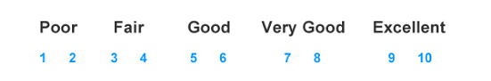

Your signature: __________________________ Date: _____________________

