**Basic Phone Tree Template**

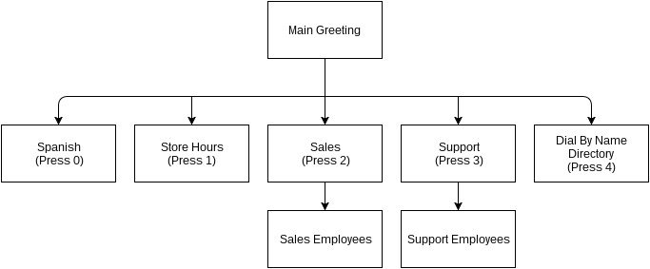

**Sales Phone Tree Template**

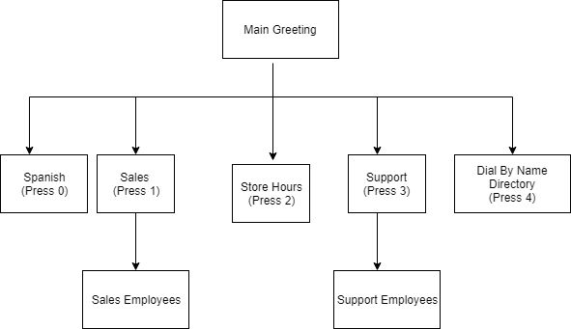

**Aggressive Sales Phone Tree Template**

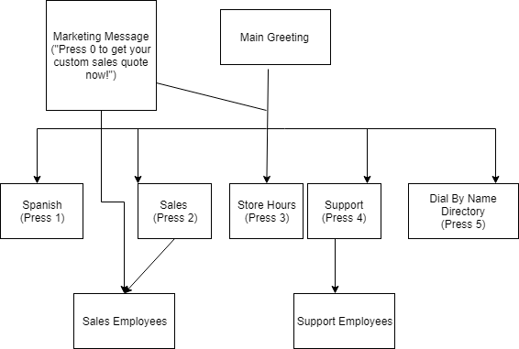

**Self-Service Phone Tree Template**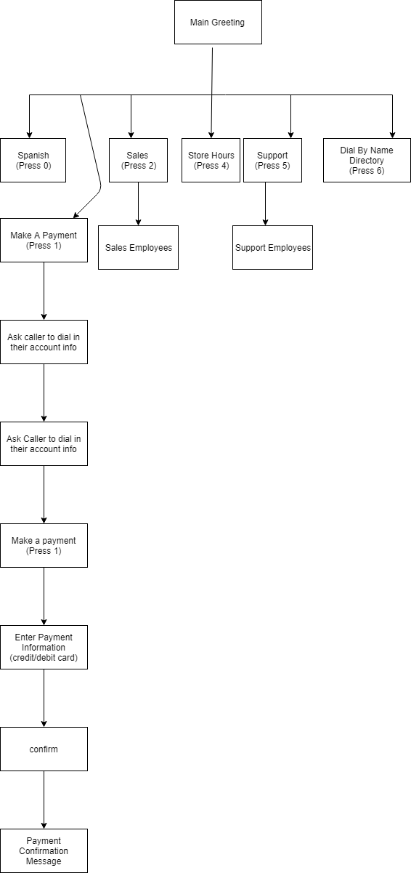

**Customer Support Phone Tree Template**

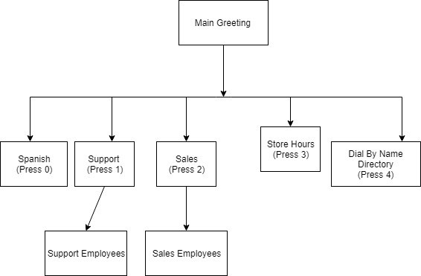

**Non-Profit Phone Tree Template**

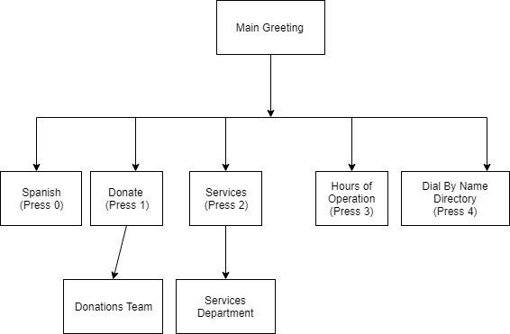

**Multi-location Phone Tree**

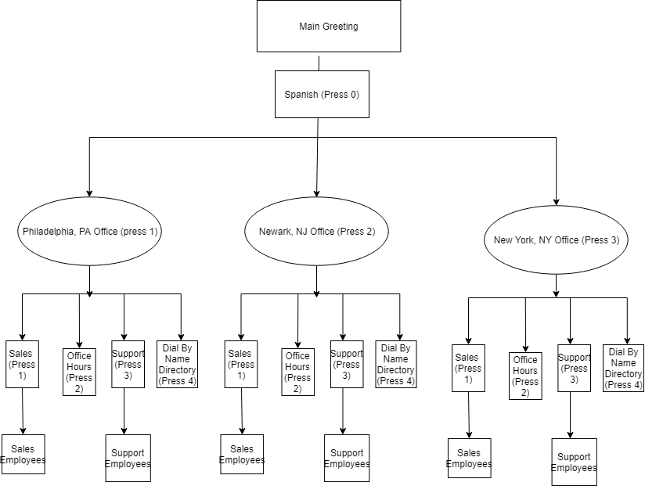

**Emergency Phone Tree Template**

