Project Scope Statement
Project Objective(s) (the goal the project is intended to achieve)
Example: Implement a CRM with all staff trained by 3rd quarter 2019 Objective 1
Objective 2

This document will help sell a project to stakeholders, keep scope creep away, and ensure the team is working together. The elements of the statement may vary by project or business but generally include objectives, description, justification, deliverables, acceptance criteria, constraints, and assumptions.

Business Objective(s) (company goal that ties into the overall business strategy)
Example: Reduce customer churn by 5% and increase new business by 15% in 2019. Objective 1
Objective 2

Description
A list of the included deliverables and the boundaries of the project. Created so internal team members and stakeholders understand what is and is not included.

In Scope: Examples
Implement a CRM to manage contacts for service and sales
It will not include internal communication automation (e.g. lead routing)

Out of Scope: Examples
Create basic product and service pipelines
It will not include internal communication automation (e.g. lead routing)

Acceptance Criteria

List of specific criteria that proves to the client that the work has been completed

Examples:

Quality assurance testing in both sandbox and “live” CRM environment has been completed and signed off by the project manager.

All employees have passed their vendor CRM certification

Constraints
List the limitations and risks that can affect a project. Primary constraints are time, scope and cost.

Example:

“The sales team is very busy selling and will have to fit the testing of the CRM into their schedules”

Work Breakdown Structure

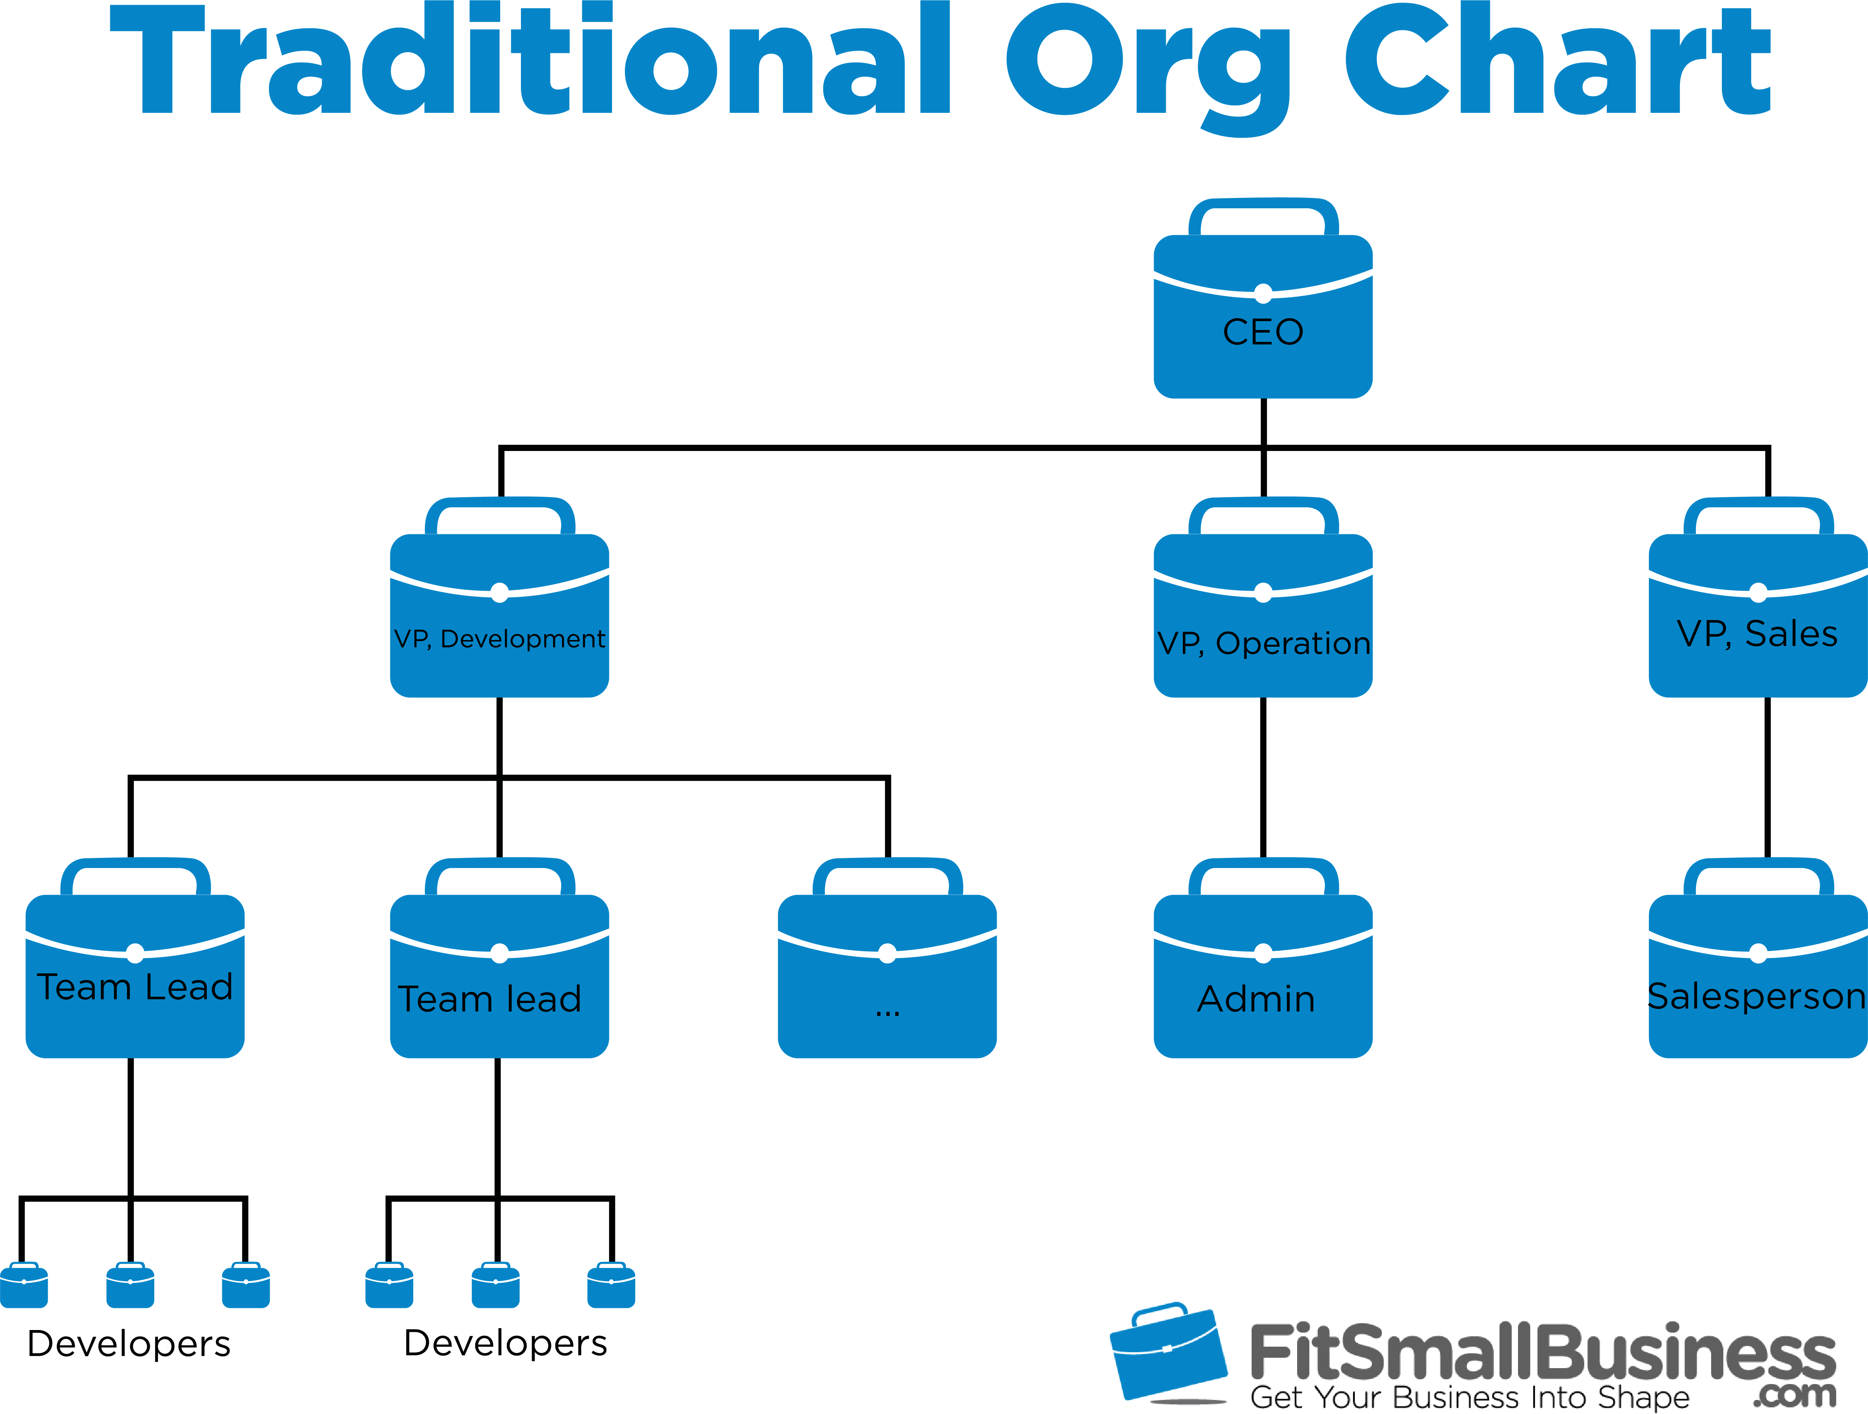

Deliverables

Work Package | Definition of work | Start Date | End Date | Resources Required | Estimated Costs

Milestones Gantt Chart

