Coffee Shop Brand Development Guide

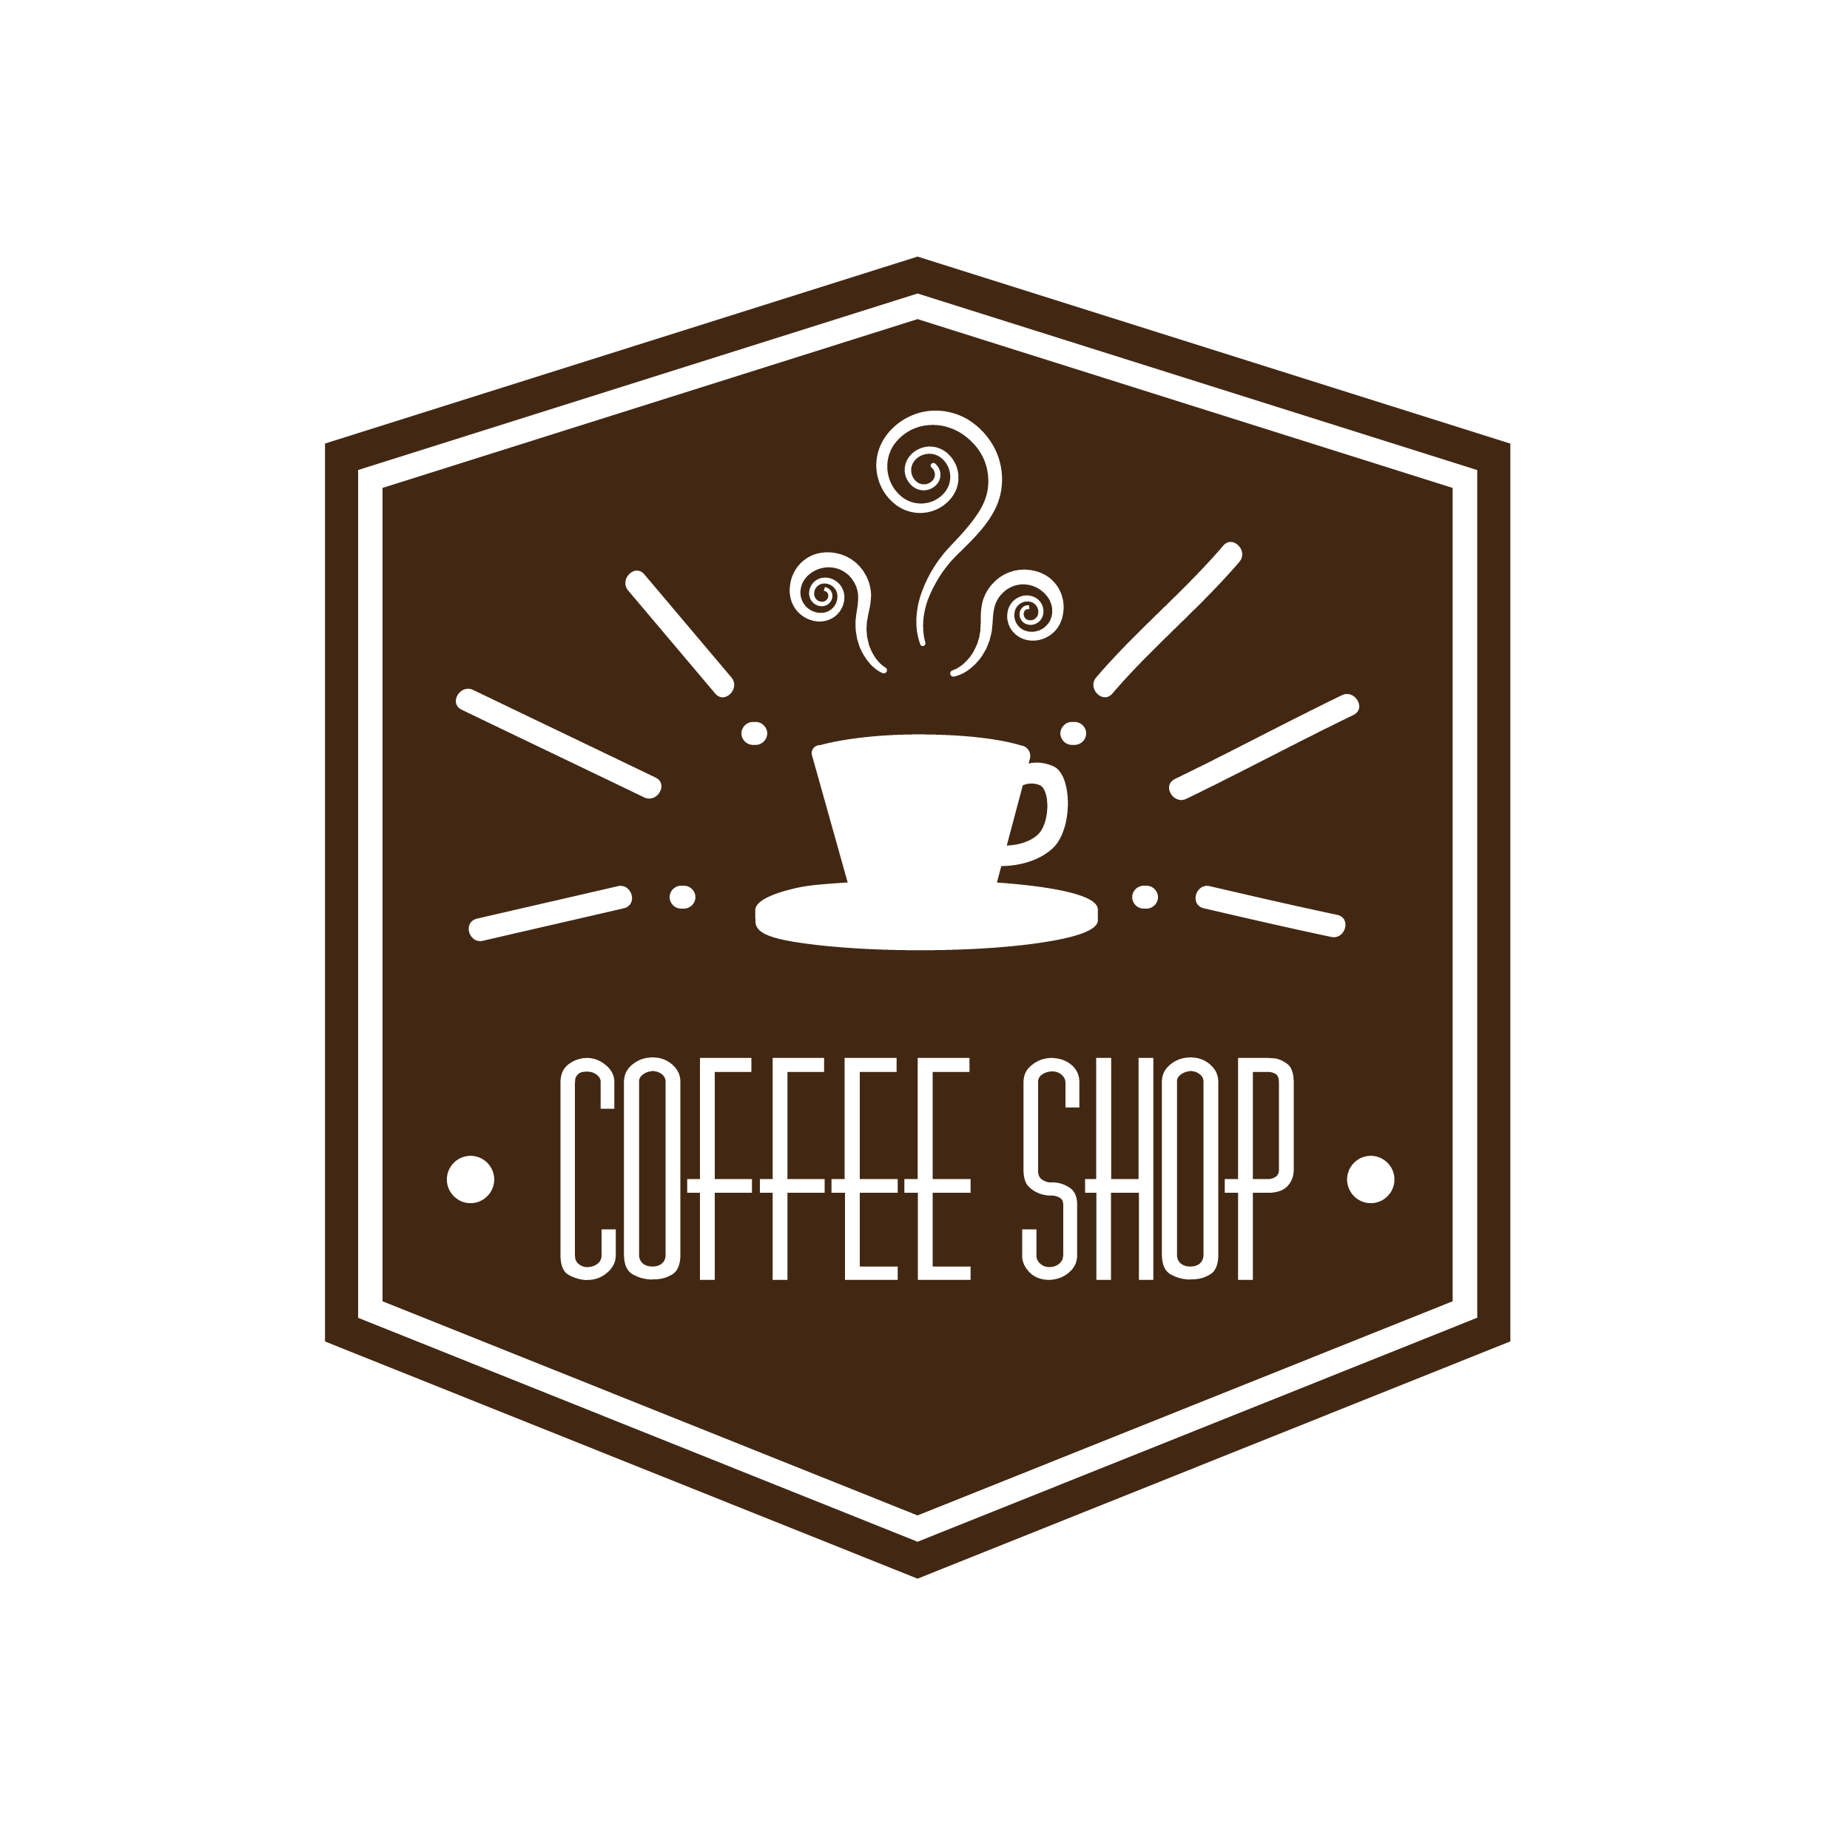

Get Clear on Your Brand Identity
Your brand identity is far more than just your logo and the colors you use in your coffee shop signage. Your brand identity is the very core of what your business is all about. It’s a combination of your values, who you want to serve, and how you want those people to feel every time they interact with your coffee shop.

Your brand identity is about your relationship with your customers. Everything you do — from developing your logo to creating signage to how you prepare and serve coffee to your customers — needs to align with a cohesive brand identity.

Before you begin the process of designing anything for your brand, make sure you’re crystal clear about the messages you want to convey. The clearer you are, the better you’ll be able to execute your brand consistently.

Here are a few questions that can help you decide what your brand is all about:

- Who are your ideal customers? What are they like?
- When people talk about your coffee shop, what do you want them to say?
- How do you want customers to feel when they enter your shop?
- What’s a song that aligns with the mood you intend to create? Why did you pick that song?
- How do you want your coffee shop to differ from other coffee shops?
- What’s the story behind why you’re starting a coffee shop?
- What are the three words that best describe your coffee shop?
- Which of the following options best describes the look and feel you want to create?
    - Upscale modern
    - Farmhouse chic
    - Playful and fun
    - Cozy home away from home
    - Artsy
    - Fast casual

Create Your Brand Mission Statement
Your brand’s mission statement is a short explanation of what your brand is all about. It should reflect what your core values are, why you’re in business, who you serve, and how you intend to serve your customers. Keep your mission statement short; a sentence or two will suffice.

Here are a few examples of mission statements from various coffee brands:

- Starbucks’ mission statement: “To inspire and nurture the human spirit — one person, one cup and one neighborhood at a time.”
- Dunkin’s mission statement: “Make and serve the freshest, most delicious coffee and donuts quickly and courteously in modern, well-merchandised stores.”
- Gloria Jean’s Coffee’s mission statement: “To be the most loved & respected coffee company worldwide.”
Refer to your mission statement throughout your brand develop process. Anytime you hire designers or writers to create promotions for you or to develop your online presence, make sure you share your mission statement with them so they have an accurate understanding of who your business is and what you intend to achieve with your coffee shop.

Develop a Mood Board
A mood board is a collection of images, fonts, and colors that together evoke the mood you want to convey in your coffee shop. You create a mood board to help guide decisions you’ll make when developing your coffee shop brand. You will share your mood board with your logo and website designers as well as refer to it when creating your coffee shop signage and selecting fixtures and furniture.

You can create a mood board by attaching pictures and magazine clippings to a poster board. Some people prefer to create their mood board on Pinterest. To do this, you simply create a new board on your Pinterest profile, label it “Coffee Shop Mood Board,” and then search Pinterest for pins that align with the look and feel you’re going for. You then save those pins to your coffee shop mood board for quick access.

Another easy way to create a mood board is via an online image-editing tool. Canva is a perfect free tool you can use to develop your mood board. Canva comes with built-in templates you can customize any way you’d like.

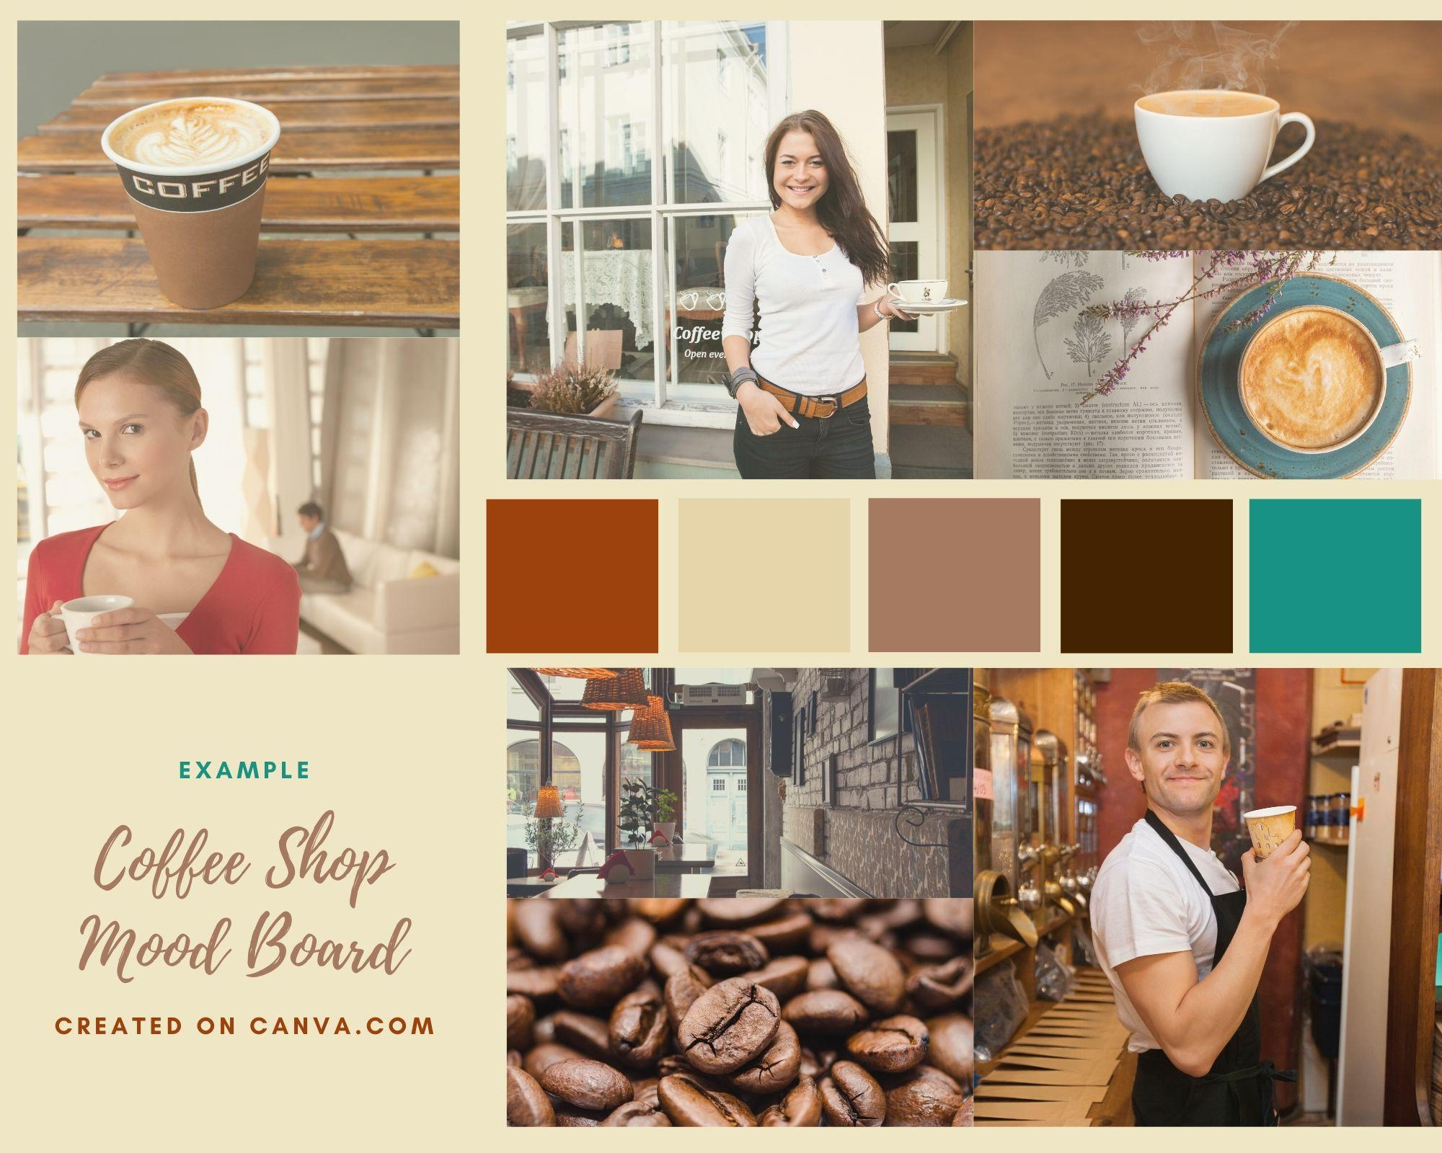
Example of coffee shop mood board created using Canva

Consider Hiring a Branding Expert
If creating a mood board is too far out of our comfort zone, you can outsource your entire brand development to a branding expert. Expect to pay between $7,000 and $40,000 for brand development services. Because the cost is too steep for some, many entrepreneurs prefer to work directly with graphic designers and direct brand development themselves.

How to Work Effectively with Designers
One of the key reasons you took the time to develop a mood board is that you’ll be working with graphic designers to develop your logo, website, product packaging, and coffee shop signage. You need to be able to communicate with designers in a way that makes your intentions and goals clear. Words alone simply are not enough; show a designer a mood board and they’ll have a much better idea of what you want.

Working with graphic and web designers can be a bit tricky. On the one hand, you want to make your needs and wants clear; a mood board helps with that. On the other hand, designers are visual experts, so you don’t want to over-direct them to the point where you’re stifling their creativity. The best way to make sure you communicate well with your designers is to communicate often.

Create Your Coffee Shop Logo
There are a number of ways to have your coffee shop logo created. One of the best and most affordable ways to have your logo developed is through 99designs. There, you can hire a designer directly or create a contest where multiple designers compete to create your coffee shop logo.

Be sure to share your mood board with designers who are working on your logo. It also helps to share examples of logos that are similar to what you want for your brand.

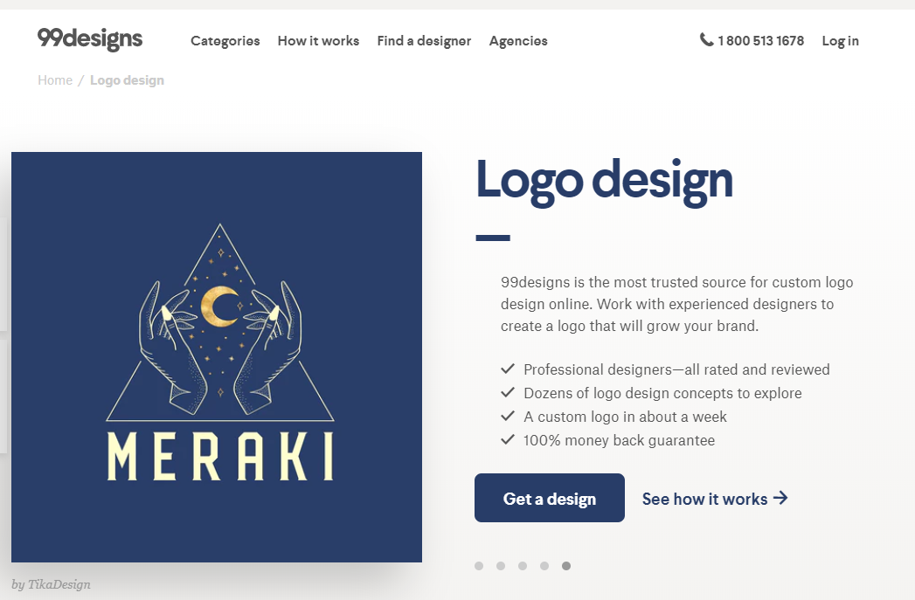
Create a logo contest on 99designs to have designers compete
to create the perfect logo for your coffee shop

Once you’ve chosen your primary logo, you may want to have your logo designer create multiple logo variations. This gives you more options to use on signage, menus, cups, aprons, t-shirts, advertisements, social media profiles, product packaging, and everywhere else you plan to post your logo.

Here are the logo variations you might want to have created:

- Full color
- Black and white
- Monochrome — using one of your brand’s core colors
- Horizontal
- Vertical or stacked
- Reversed logo

You also want to have a version of your logo that includes your brand’s slogan or tagline — provided you have one. Developing some logo versions with your slogan and some without allows for maximum design flexibility.

You may also want to have your designer create a logo mark for you. This is a simplified version of your logo that doesn’t contain your full business name, but rather is an image that represents your business. You’ll use logomarks whenever using the full logo is impractical or overkill.

Examples of Coffee Shop Logos

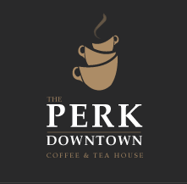
The Perk Downtown Coffee & Tea House in Colorado Springs, CO

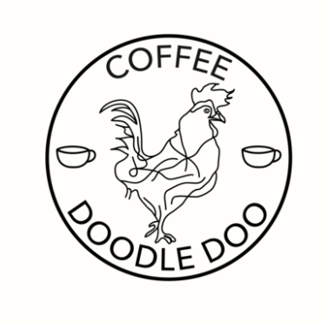
Coffee Doodle Doo in Portland Oregon

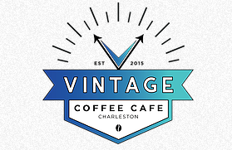
Vintage Coffee Cafe in Charleston, SC

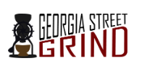
Georgia Street Grind in Indianapolis, Indiana

Create a Brand Style Guide
Once your logo is developed, you’ll want to work with a designer to create a brand style guide for your coffee shop. In your mood board, you added all types of images, fonts, and colors that you liked, but now it’s time to get specific about what you want and don’t want. Your brand style guide defines specific colors and typography that will be used when developing anything that requires brand visuals.

Specific elements to include in your brand style guide:

- Color palette: These are the core colors for your brand. Your guide should list specific color codes. Most businesses have 4 to 6 colors in their brand color palette.
- Typography: This is a list of the specific typefaces to use, as well as the relative hierarchy of each, as most brands often use a different font or typeface for headlines, subheads, and body text. Brand guides may also include directions for when italic, bold, and various font sizes should be used.
- Logos: Your brand style guide should include all the logo variations you’ve developed for your coffee shop brand.
- Image Inspiration: You may also want to include a few images for design inspiration on your brand style guide.
Think of your brand style guide as the visual playbook you’ll use whenever you develop anything that contributes to the aesthetic of your coffee shop brand. It’s a must-have tool in your business toolbox.
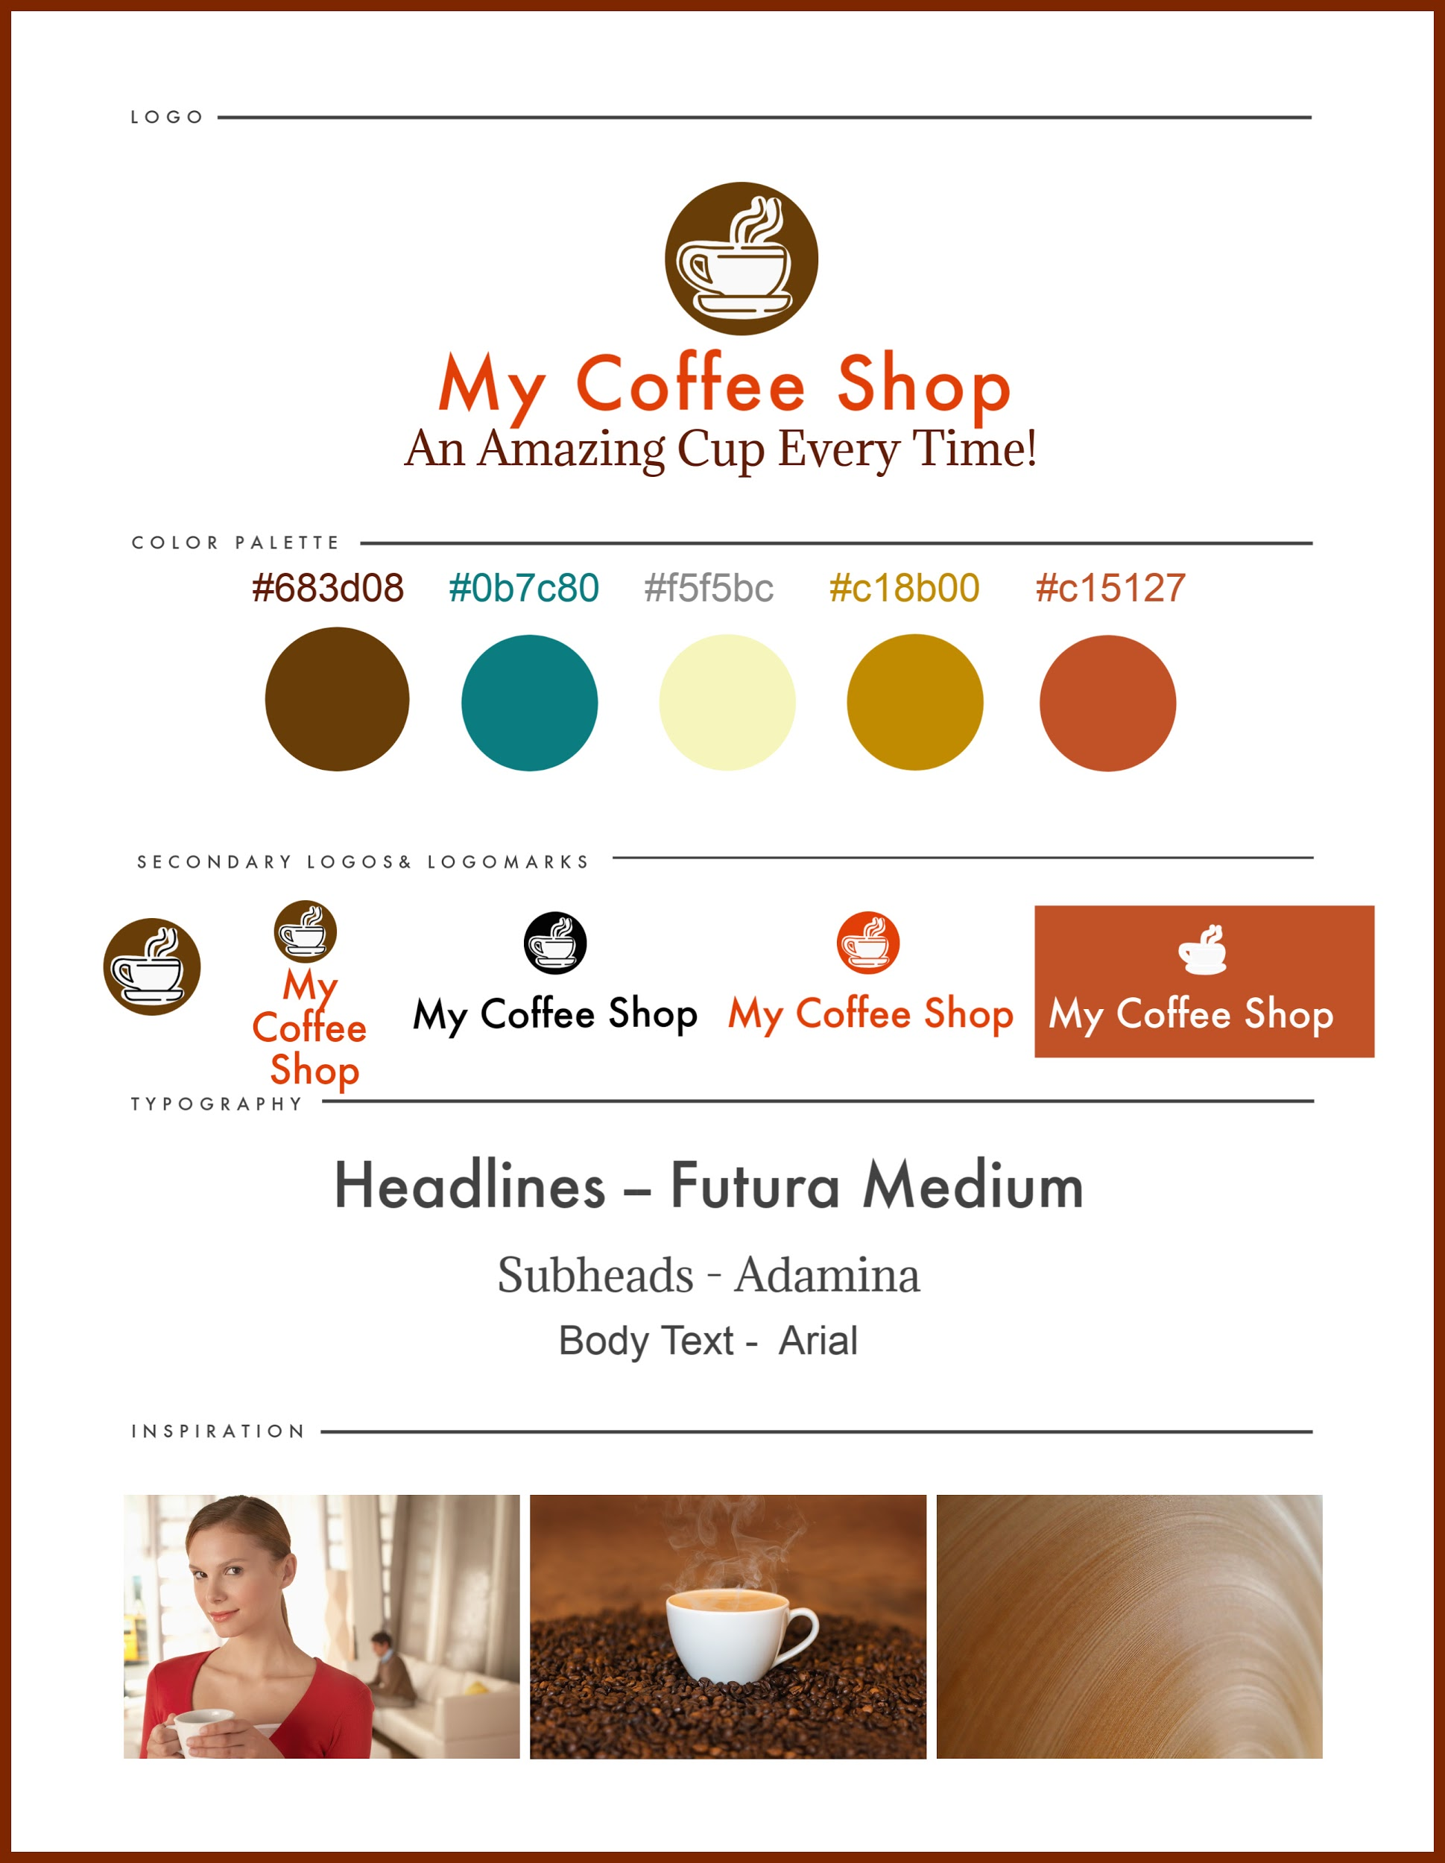

Example of a Brand Guide for a Coffee Shop created using PicMonkey

Execute Your Brand Consistently
Brand consistency is the act of uniting all your coffee shop efforts with one voice and a common visual aesthetic. It involves using the same color schemes, typography, and logos throughout your shop. It also involves conveying the heart of your mission in everything you do — from signage to how you greet and serve customers.

At its essence, your brand is your coffee’s shop’s personality. When you’re inconsistent with brand execution, you confuse customers. When you’re consistent, you build understanding and trust. When you wow your customers with excellence with every encounter, you earn customers for life.

