Reference Guide:

Business Registrations, Licenses, & Permits

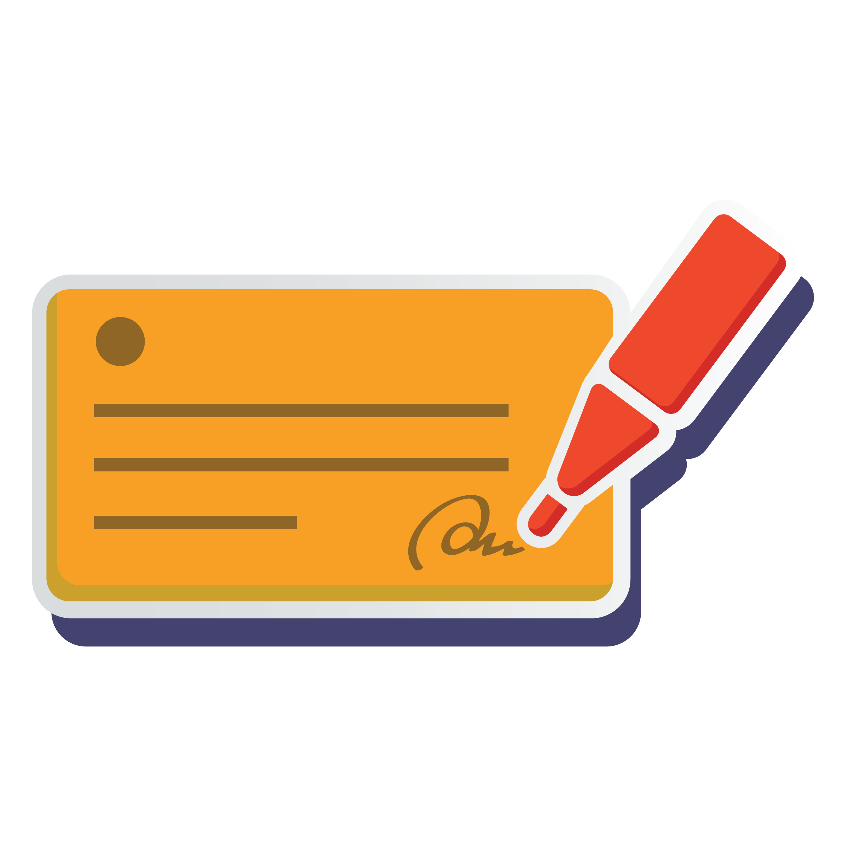

Note: This reference guide is for educational purposes only. We urge you to consult an attorney or someone familiar with federal, state, and local laws that might apply prior to launching your coffee shop business.

Business Registrations, Licenses & Permits You May Need:*
Required permits and licenses vary by location. Consult an attorney or your local Small Business Administration office for exact requirements in your area.
- Employer Identification Number (EIN): Issued by the IRS, an EIN is required for all business owners in the U.S.
- Business License: When required, business licenses grant you the right to conduct business in a certain area. These can be issued on a state and/or local level.
- Local Foodservice License: Issued by your city or county health department
- Sales Tax License (or Vendor’s License): Issued by your state, a sales tax license grants you the right to collect sales tax from customers and requires you to remit the collected tax to the state.
- Resale License/Permit: This state-issued license or permit allows you to buy wholesale goods that you plan to resell in your business or use to create goods to sell in your business.
- Certificate of Occupancy: Issued by local government agencies that certify the building is compliant with codes and is suitable for occupancy.
- Food Handler’s Permit: Sometimes required for every coffee shop employee, Food Handlers’ Permits are issued by your city or county health department.
- Building Health Permit: These permits are issued by your city or county health association. All coffee shops are subject to occasional health inspections by the local governing health department to ensure food handling, preparation, and storage practices are safe.
- Outdoor Sign Permit: Some cities have strict codes and guidelines pertaining to outdoor signage. Be sure to check with your city before buying and installing a sign for your coffee shop.
- Dumpster Placement Permit: Some localities require a permit before you can place a dumpster near your Coffee Shop.
- Foodtruck Permit: If you plan on starting a food truck coffee business, check with your local health department and city administrators for required licenses and permits.
- Music License: If you want to play copyrighted music in your cafe, you must obtain a license through the Broadcast Music Inc (BMI) or the American Society of Composers, Authors, and Publishers (ASCAP).
- Liquor License: If you plan to offer liquor in your shop, you’ll need a liquor license issued by your state).

Other Helpful Resources for Coffee Shop Owners
- What Is a Sole Proprietorship?
- LLC vs S Corp vs. Corp: Best Small Business Structure?
- LegalZoom vs Rocket Lawyer: Which Is Best?
- Small Business Tax Rates: How Much Businesses Actually Pay in Taxes
- How to Set Up an LLC on LegalZoom in 7 Steps
- Restaurant Loans: Costs, Financing Terms & Providers
- Restaurant Insurance Cost, Coverage & Providers
- Zoning Laws for Small Business: What You Need to Know
- Free Payroll Templates
- 7 Best Payroll Services & Payroll Employees
- 7 Best Restaurant Scheduling Software & Apps
- Best Mobile Credit Card Processing Options
- 8 Best Restaurant POS Systems
- 6 Best Restaurant Inventory Management Software
- Federal Labor Laws & State Employment Laws
- Employee Handbook: Definition, Features & Costs [+ Free Sample]

