Coffee Shop Business Plan
Template

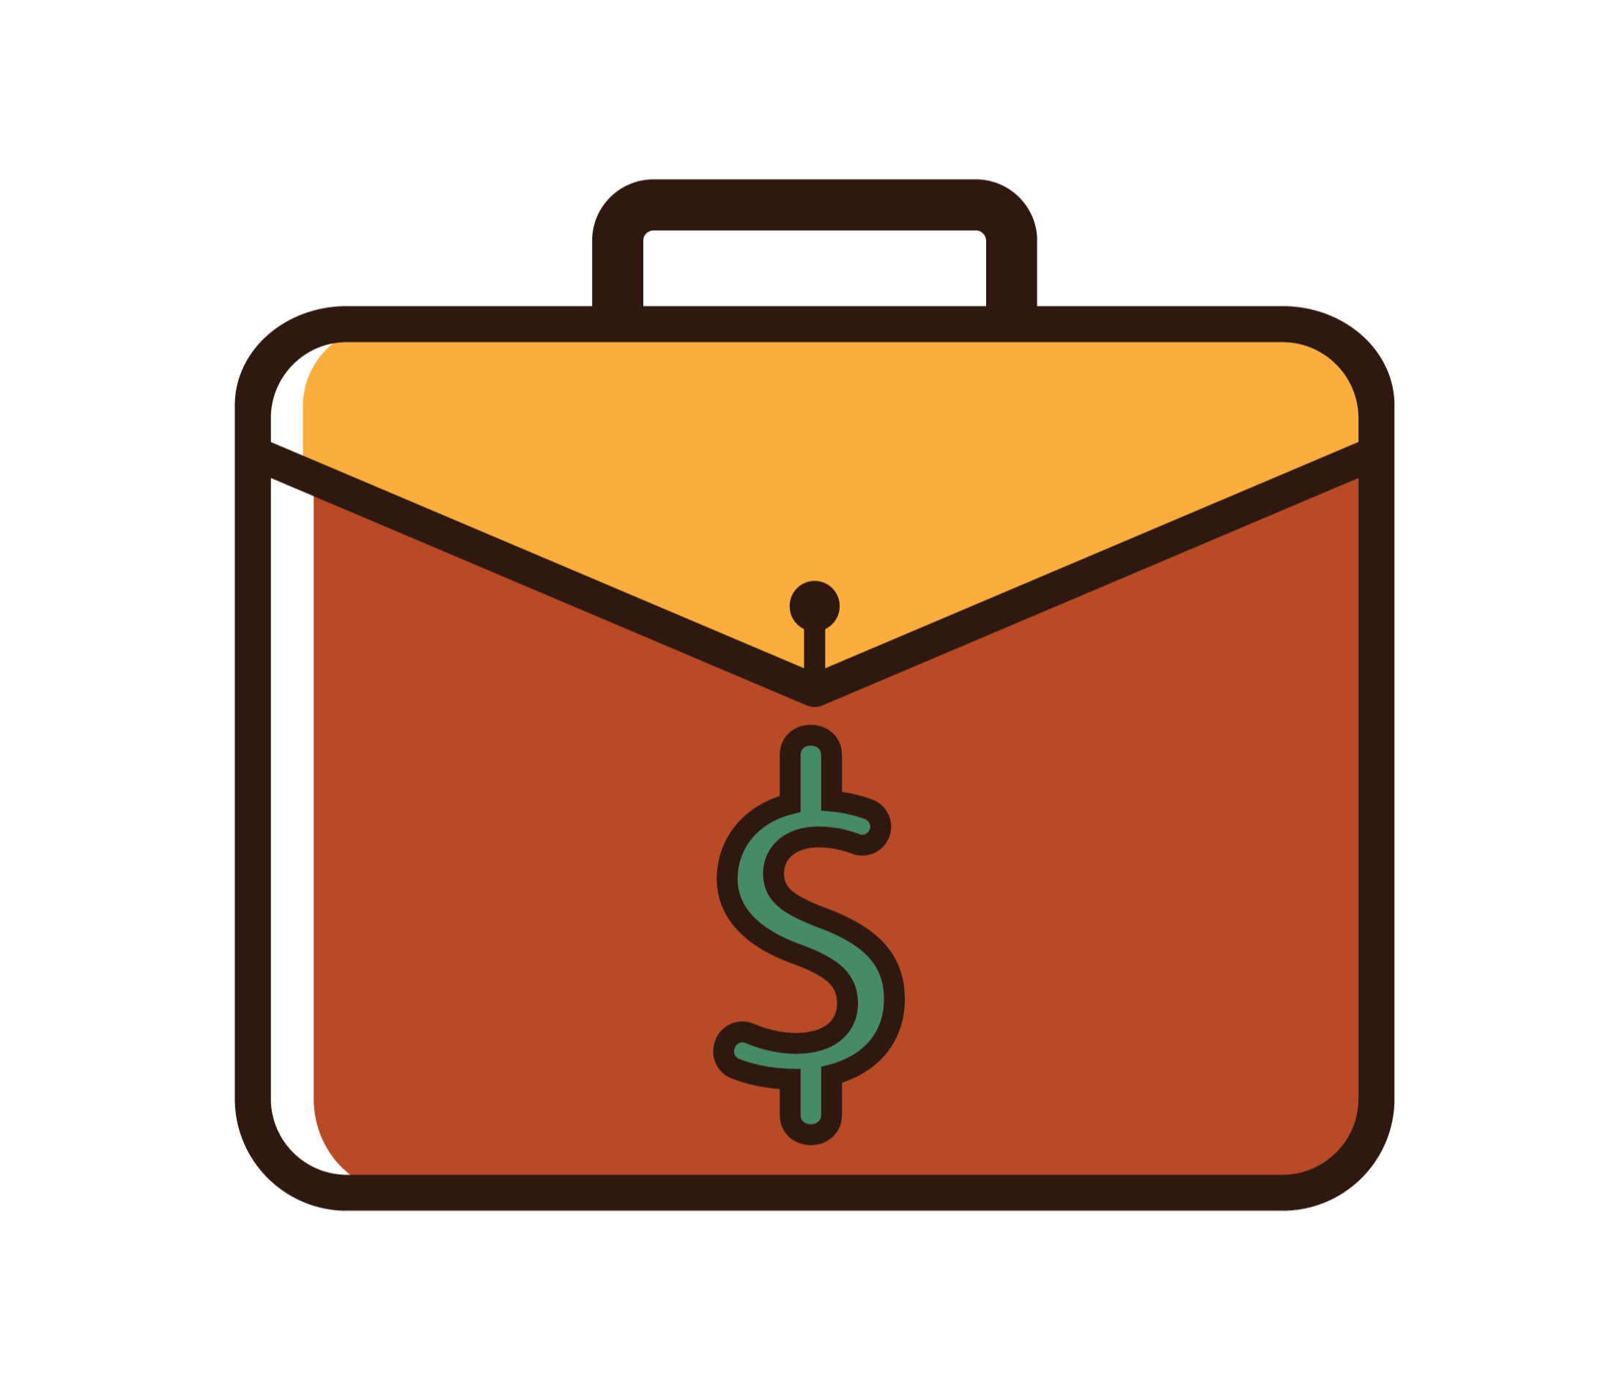

(Coffee Shop Name)

(Company Name)
(Street Address)
(City, State, Zip Code)
(Creation Date)

Contact Information
(Name)
(Email)
(Phone Number)
(Website)

Table of Contents

1.0 Executive Summary 4
1.1 Business Objectives 4
1.2 Mission Statement 4
1.3 Keys to Success 4
2.0 Company Summary 5
2.1 Startup Summary 5
2.2 Location & Facility 5
2.3 Ownership & Management 5
3.0 Food, Products & Services 6
3.1 Product Description 6
3.2 Daily Operations and Production 6
3.3 Pricing and Profitability 6
4.0 Market & Industry Analysis Summary 7
4.1 Market Segmentation 7
4.2 Target Market Segment Strategy 7
4.3 Main Competitors 7
5.0 Marketing Strategy & Implementation Summary 8
5.1 Competitive Advantage 8
5.2 Marketing Strategy & Positioning 8
5.3 Traditional Marketing & Advertising 8
5.4 Online Marketing & Advertising 8
5.5 Sales Strategy & Forecast 8
5.6 Restaurant Milestones 8
6.0 Financial Plan & Projections 8
6.1 Startup Costs 8
6.2 Break-even Analysis 9
6.3 Projected Profit & Loss 9
6.4 Projected Cash Flow 9
6.5 Projected Balance Sheet 9
6.6 Business Ratios 9
7.0 Appendix 9

1.0 Executive Summary
In the opening paragraphs, discuss the most important aspects of the business plan. The entire executive summary should be less than two pages.

1.1 Business Objectives
What do you want your coffee shop to achieve? Include at least five objectives. Make specific and actionable.

1.2 Mission Statement
A brief statement or paragraph describing what your coffee shop stands for.

1.3 Keys to Success
What are the factors that will make your business a success? Include at least three.

2.0 Company Summary
Open with a couple of paragraphs describing your coffee shop including important facts, like address, hours, sq. footage.

2.1 Startup Summary
Briefly, how much will it cost to start your business? Consider creating a chart with each expense.

2.2 Location & Facility
Where is your business located? What makes the location a benefit? What’s the facility like? How will the facility increase your likelihood of success?

2.3 Ownership & Management
Who are the owners of the coffee shop? What are their backgrounds and why will that make the business a success? What is the management structure like within the coffee shop? Who are the managers?

3.0 Food, Products & Services
Write a couple paragraphs with a high-level overview describing the drinks, food, and products you intend to sell.

3.1 Product Description
What types of coffee drinks will be served? What other food products or merchandise will your coffee shop sell?

3.2 Daily Operations and Production
What are the day-to-day operations and systems that make your coffee shop operate? Who will take care of tasks like inventory management, tip payout, cleaning, and opening the shop?

3.3 Pricing and Profitability
What is the price of every item on the menu and how much will you make on a sale? Create a chart.

4.0 Market & Industry Analysis Summary
Describe the industry your coffee shop is in. What are the trends? It is predicted to be a growing or shrinking market?

4.1 Market Segmentation
Who are the types of customers that will visit your coffee shop? Use data to explain their purchasing habits and how many are in your area.

4.2 Target Market Segment Strategy
How will you reach your different segments of customers? How will you communicate to them?

4.3 Main Competitors
Who are your main competitors within a five mile radius? List at least five. Include a chart with details like distance, description, advantages and disadvantages.

5.0 Marketing Strategy & Implementation Summary
Give a high level overview of your marketing strategy and how it will be implemented.

5.1 Competitive Advantage
What will you do better than competing coffee shops?

5.2 Marketing Strategy & Positioning
What are your strategies to market your business? Additionally, how will you communicate your coffee shop in a 30-second positioning statement?

5.3 Traditional Marketing & Advertising
What type of physical marketing and advertising will you do? Where will the materials be made?

5.4 Online Marketing & Advertising
What online marketing and advertising will you do? Who will manage it?

5.5 Sales Strategy & Forecast
What are your sales, costs, and profits forecast for the first three years? Create a chart.

5.6 Coffee Shop Milestones
What are the main milestones you need to reach before opening your business? Have at least eight.

6.0 Financial Plan & Projections
What are the assumptions you made about the economy and your coffee shop for the financial projections below?

Use this financial projections worksheet (https://www.score.org/resource/financial-projections-template ) as a guide to the sections below. Ideally, turn the projections into charts for investors and bankers to more easily understand the numbers.

6.1 Startup Costs
How much money will it require to open the shop? List the expenses and include cost.

6.2 Break-even Analysis
At what point in sales will the business operate at a profit?

6.3 Projected Profit & Loss
What are the income and expenses in the coffee shop and at what month will it operate at a profit?

6.4 Projected Cash Flow
How much cash is coming into and going out of the shop by month?

6.5 Projected Balance Sheet
What are projected assets and liabilities of the business for the next three years?

6.6 Business Ratios
What are the business ratios at the end of year one, two and three?

7.0 Appendix
Include additional documentation to support the business plan. Include any visual documentation, like a floor plan or artist rendering. It’s recommended to include a sample menu.

