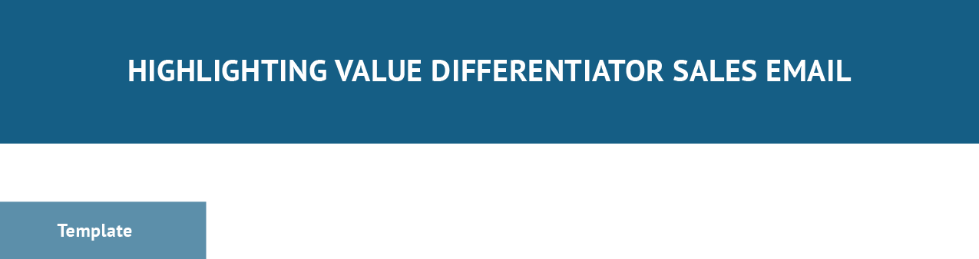

Subject Line: [Tease Unique Value You Can Provide to {Lead Name}]

Hi [contact name],

I saw that [add context of something about the lead that would make them a good fit for your product or service]. [Explain your products or services/what you offer].

[Describe what makes you unique from others in your industry] I’d love to schedule a call and [describe intentions with prospect]. [Initiate Call to Action]
Thank you, [Name], [Title] [Company] [Email]
[Phone Number]

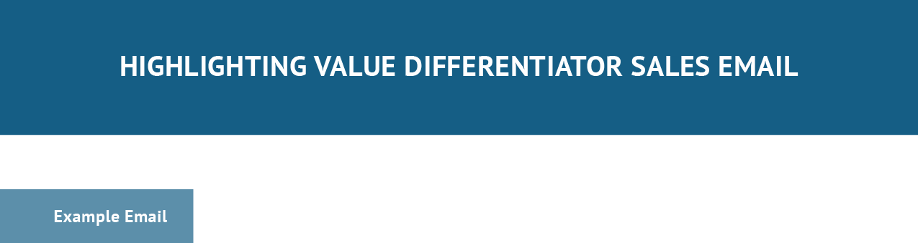

Subject Line: Giving ABC Tax Company Peace of Mind with Custom Data Security Solution

Hi John,

I saw that you provide both tax preparation and bookkeeping services which means you’re managing a lot of sensitive information —making you vulnerable to data-security threats. Our comprehensive cybersecurity consulting solutions allow you to rest easy by being a central source for all of your planning, technology, and compliance needs.

Our services are fully customizable to fill in your security gaps in terms of what you need and what your IT management firm is not providing.

I’d love to schedule a call and learn more about some of the pain points you experience in cybersecurity planning and identify potential gaps within your current cybersecurity program.

Are you free in the next few days or so for a 10-minute call? Thank you,
Cameron Eck, Account Executive Cybersecurity Corp. cam@cybersecuritycorp.com 123-456-7890

Subject Line: [Reference the Event]

Hi [contact name],

[Cite if the contact has seen the recent story or release of new information you’re referencing]. [Discuss the implications/how it can affect this particular lead].

[Explain what promotion you are offering as a result of the event or state your unique selling proposition]

[Initiate Call to Action] Thank you,
[Name], [Title] [Company] [Email]
[Phone Number]

Subject Line: New Industry Report Reveals Automation is the Future

Hi Madison,

You may have recently seen the 2022 Marketing Industry Report that found a majority of businesses, including ones within your industry, are easing into marketing automation as their primary strategy for building customer relationships.

Automation lets you target or re-target your ideal audiences, gather their information, and nurture leads all hand-free for more lead-volume production—ultimately producing higher revenue growth.

That being said, we are offering free consultations for retail, wholesale, and eCommerce businesses to see where they may be able to utilize automation in their marketing campaigns.

If you or anyone in your office would like to take advantage of this offer, the link to schedule an appointment with a consultant is below.

Thank you,

Cameron Eck, Account Executive Marketing Inc. cam@marketinginc.com
123-456-7890

[Schedule Appointment Button]

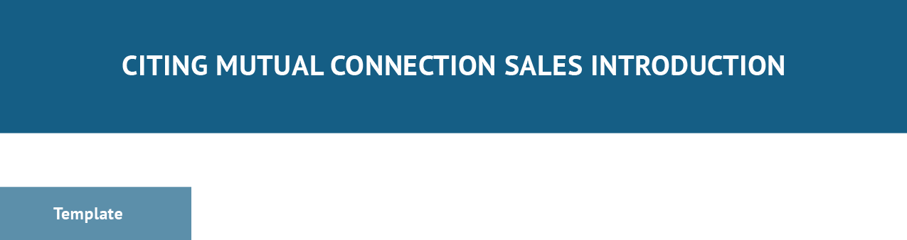

Subject Line: [Cite mutual connection]

Hi [contact name],

[Cite mutual connection or decision maker and (if necessary) something you know about the lead]. [Explain your intentions and selling/value proposition]
[Initiate Call to Action] Thank you,
[Name], [Title] [Company] [Email]
[Phone Number]

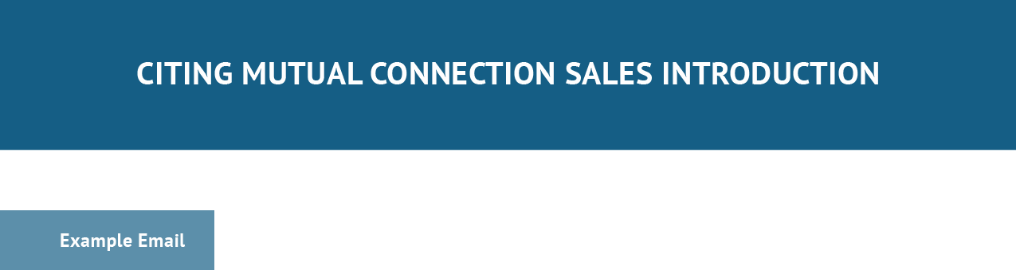

Subject Line: Madison Batts Told Me to Connect With You

Hi Rick,

Madison Batts mentioned to me briefly that you were having some issues with your current financial adviser and looking for a switch.

I’d love to schedule a quick call and show you how our personal planning resources and access to a multitude of financial products can get you on track to hit your wealth goals.

Do you have 15 minutes open this week? Looking forward to hearing back and connecting. Thank you,
Cameron Eck, Adviser Wealth Management Inc.
cam@wealthmanagementinc.com 123-456-7890
[Schedule Appointment Button]

Subject Line: Great Speaking with You at [Reference event or call you’re following up on]

Hi [contact name],

[Address the event you met them at and/or how great it was speaking with them (if cold calling).

[Acknowledge or reference something they mentioned at the event or on the call that had you send them a follow-up email]

[Explain the selling proposition or next steps (if cold calling) required to move forward in the process] [Initiate Call to Action]
Thank you, [Name], [Title] [Company] [Email]
[Phone Number]

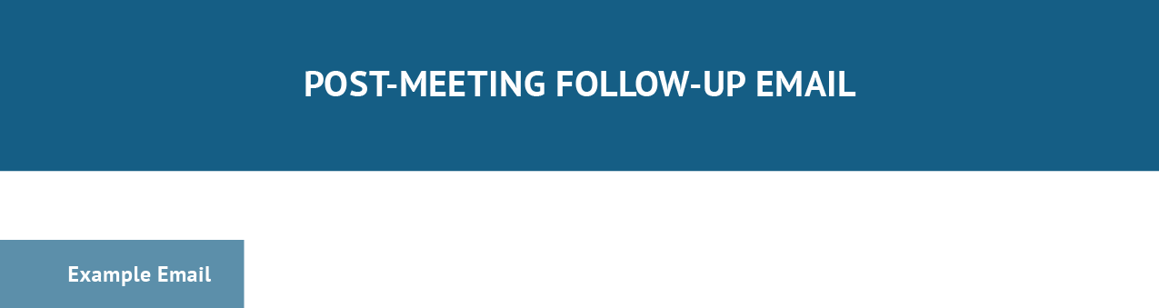

Subject Line: Great Meeting You at the Chamber Event

Hi Joe,

It was a pleasure to meet you at the Arlington Chamber of Commerce event last week. I hope you enjoyed the presentations and mingling as much as I did.

You mentioned you were looking for quotes for your upcoming insurance renewal. We produce competitive premiums thanks to our wide range of carrier partnerships, which offer plenty of flexibility and options.

Let me know if you are interested and I will arrange a brief meeting to discuss. Thank you,
Cameron Eck, Producer ABC Insurance Inc. cam@abcinsurance.com 123-456-7890
[Schedule Appointment Button]

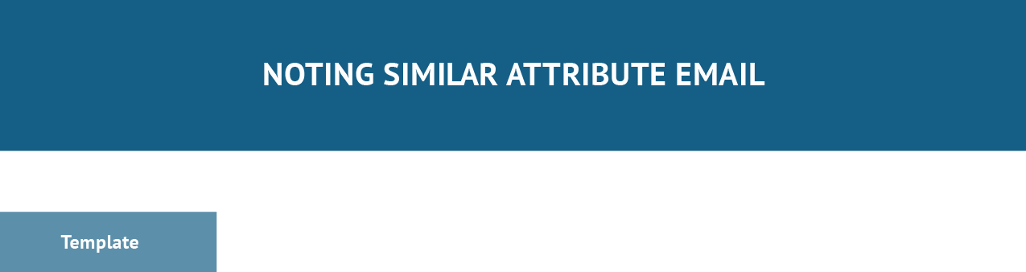

Subject Line: [Specifically cite the mutual or similar attribute]

Hi [contact name],

[Introduce yourself and cite similar attribute(s) for interests, hobbies, etc]. [Explain intentions and touch on your solution]
[Possibly discuss unique value proposition] [Initiate Call to Action]
Thank you, [Name], [Title] [Company] [Email]
[Phone Number]

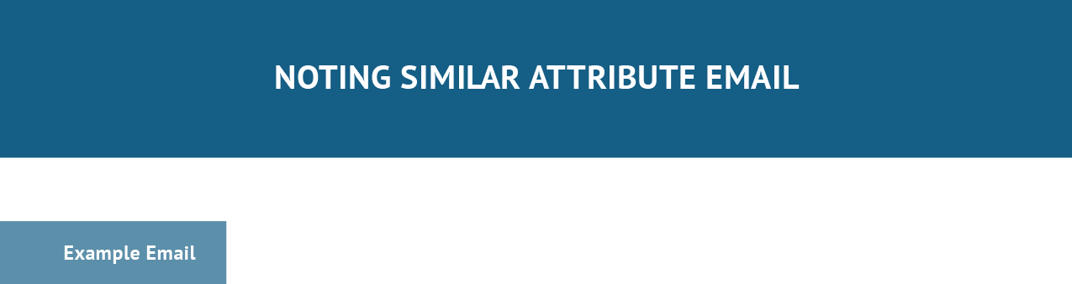

Subject Line: Fellow JMU Duke

Hi Sydney,

My name is Cameron Eck, I saw on LinkedIn that you are a fellow graduate from James Madison University and a business owner in the technology space.

I’m looking to connect with other software vendors and technology consultants to talk about my innovative solution to managing software development and client infrastructure projects.

Are you interested in learning more about it? I’d love to set up a few minutes for us to talk. Thank you,
Cameron Eck, Founder ABC Tech cam@abctech.com 123-456-7890
[Schedule Appointment Button]

Subject Line: [Describe what you’re praising the contact for]

Hi [contact name],

[Introduce yourself and praise something they did, accomplished, or contributed to, and describe how it may have impacted you].

[Describe intentions and how they can add value to the recipient with an optional value proposition on what your business does]

[Initiate Call to Action] Thank you,
[Name], [Title] [Company] [Email]
[Phone Number]

Subject Line: Excellent Sales Seminar

Hi Mel,

My name is Cameron Eck from Writing Agency Inc. I loved your sales seminar last week as it shed valuable insight on where social selling and referral marketing is heading into the future.

I’m looking to tap into some of the markets you commonly work with like software vendors and automation consultants and would love to talk about potential partnerships between our firms. We generate high-quality content primarily for tech businesses using writers who have expertise and experience in the fields they write about. That said, we can definitely offer each other plenty of referral opportunities through our similar target markets.

Are you interested in discussing this further? I’d love to set up a few minutes for us to talk. Thank you,
Cameron Eck, Content Manager Writing Agency Inc. cam@writingagencyinc.com 123-456-7890
[Schedule Appointment Button]

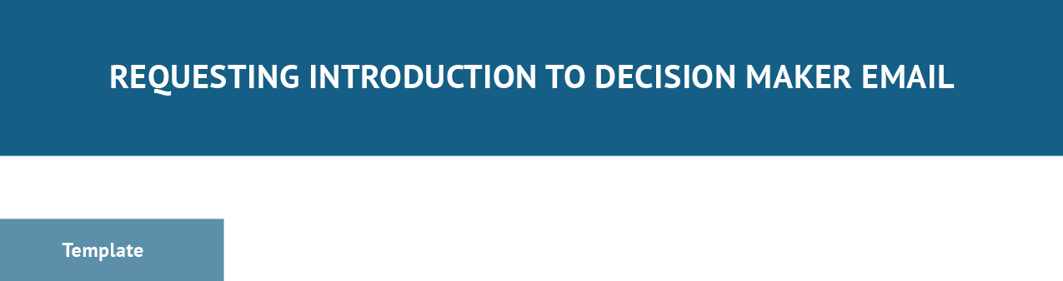

Subject Line: [Describe intention for {lead name} with value proposition phrase]

Hi [possible contact name if you have it],

[Introduce yourself and business, solution offering, and value proposition] [Describe intention/request decision maker contact info or referal] [Initiate Call to Action]
Thank you, [Name], [Title] [Company] [Email]
[Phone Number]

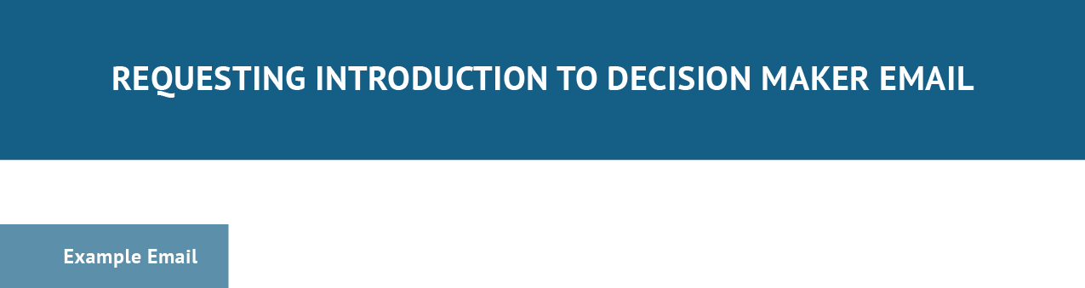

Subject Line: Hoping to Help ABC Accounting Streamline Data Management

Hi,

My name is Cameron Eck from Management Software Inc, a provider of a simplistic solution to managing data migration and analytics projects for accounting firms.

I was hoping to get in contact with someone from ABC Accounting who might make decisions on productivity software.

Can you please guide me in the right direction by providing that person’s contact info? Thank you,
Cameron Eck, Account Executive Management Software Inc. cam@projectmanagement.com 123-456-7890
[Schedule Appointment Button]

