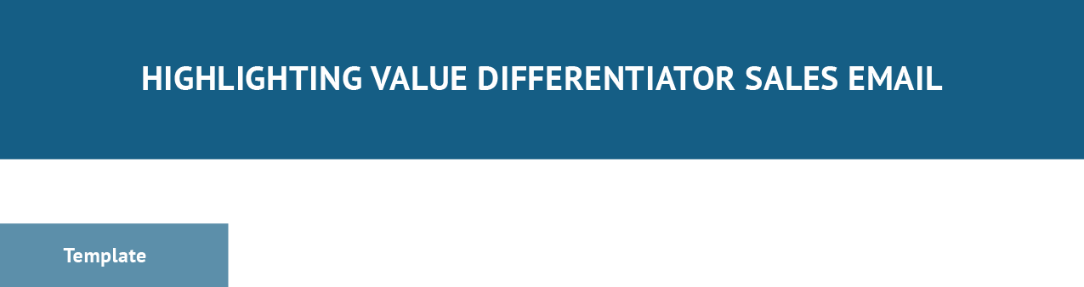

Subject Line: [Tease Unique Value You Can Provide to {Lead Name}]

Hi [contact name],

I saw that [add context of something about the lead that would make them a good fit for your product or service]. [Explain your products or services/what you offer].

[Describe what makes you unique from others in your industry] I’d love to schedule a call and [describe intentions with prospect]. [Initiate Call to Action]
Thank you, [Name], [Title] [Company] [Email]
[Phone Number]

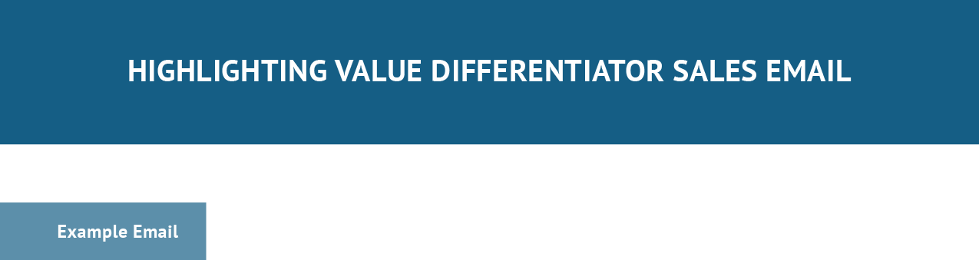

Subject Line: Giving ABC Tax Company Peace of Mind with Custom Data Security Solution

Hi John,

I saw that you provide both tax preparation and bookkeeping services which means you’re managing a lot of sensitive information —making you vulnerable to data-security threats. Our comprehensive cybersecurity consulting solutions allow you to rest easy by being a central source for all of your planning, technology, and compliance needs.

Our services are fully customizable to fill in your security gaps in terms of what you need and what your IT management firm is not providing.

I’d love to schedule a call and learn more about some of the pain points you experience in cybersecurity planning and identify potential gaps within your current cybersecurity program.

Are you free in the next few days or so for a 10-minute call? Thank you,
Cameron Eck, Account Executive Cybersecurity Corp. cam@cybersecuritycorp.com 123-456-7890

