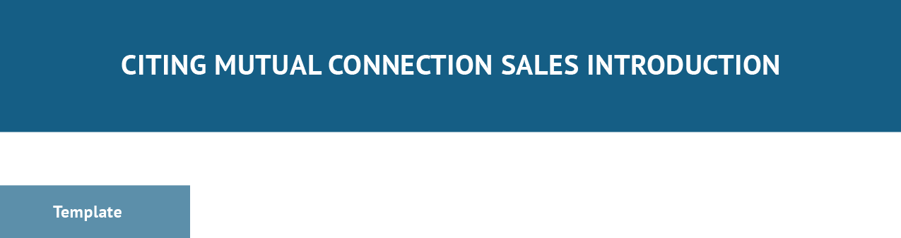

Subject Line: [Cite mutual connection]

Hi [contact name],

[Cite mutual connection or decision maker and (if necessary) something you know about the lead]. [Explain your intentions and selling/value proposition]
[Initiate Call to Action] Thank you,
[Name], [Title] [Company] [Email]
[Phone Number]

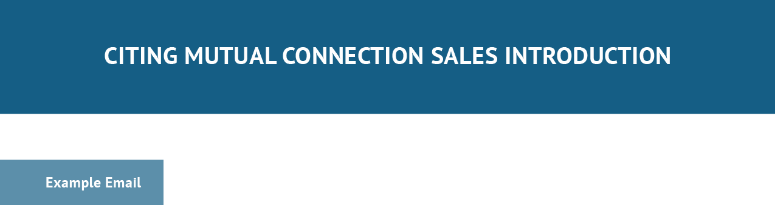

Subject Line: Madison Batts Told Me to Connect With You

Hi Rick,

Madison Batts mentioned to me briefly that you were having some issues with your current financial adviser and looking for a switch.

I’d love to schedule a quick call and show you how our personal planning resources and access to a multitude of financial products can get you on track to hit your wealth goals.

Do you have 15 minutes open this week? Looking forward to hearing back and connecting. Thank you,
Cameron Eck, Adviser Wealth Management Inc.
cam@wealthmanagementinc.com 123-456-7890
[Schedule Appointment Button]

