Subject Line: [Specifically cite the mutual or similar attribute]

Hi [contact name],

[Introduce yourself and cite similar attribute(s) for interests, hobbies, etc]. [Explain intentions and touch on your solution]
[Possibly discuss unique value proposition] [Initiate Call to Action]
Thank you, [Name], [Title] [Company] [Email]
[Phone Number]

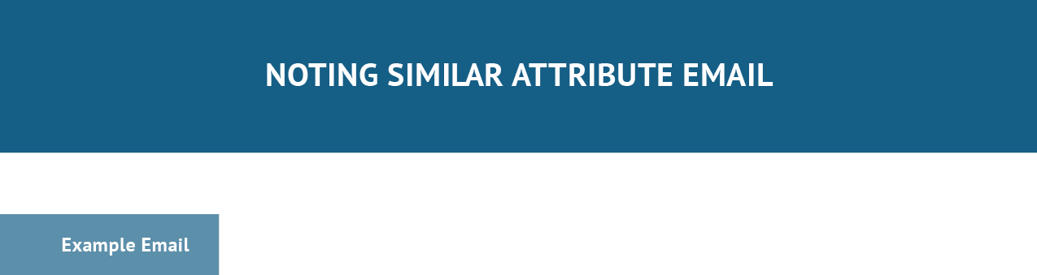

Subject Line: Fellow JMU Duke

Hi Sydney,

My name is Cameron Eck, I saw on LinkedIn that you are a fellow graduate from James Madison University and a business owner in the technology space.

I’m looking to connect with other software vendors and technology consultants to talk about my innovative solution to managing software development and client infrastructure projects.

Are you interested in learning more about it? I’d love to set up a few minutes for us to talk. Thank you,
Cameron Eck, Founder ABC Tech cam@abctech.com 123-456-7890
[Schedule Appointment Button]

