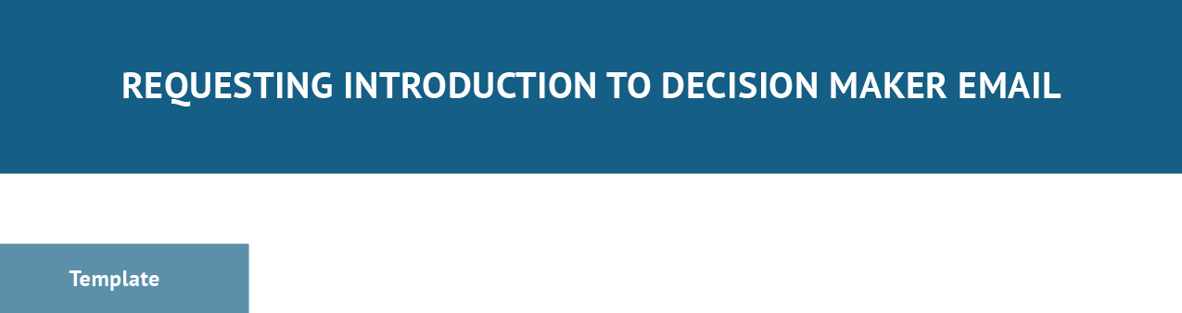

Subject Line: [Describe intention for {lead name} with value proposition phrase]

Hi [possible contact name if you have it],

[Introduce yourself and business, solution offering, and value proposition] [Describe intention/request decision maker contact info or referal] [Initiate Call to Action]
Thank you, [Name], [Title] [Company] [Email]
[Phone Number]

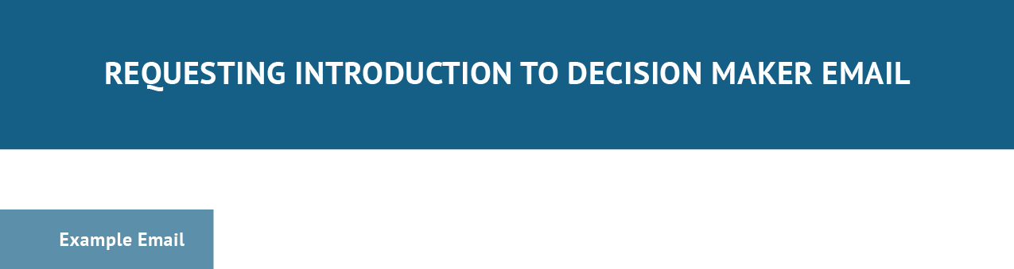

Subject Line: Hoping to Help ABC Accounting Streamline Data Management

Hi,

My name is Cameron Eck from Management Software Inc, a provider of a simplistic solution to managing data migration and analytics projects for accounting firms.

I was hoping to get in contact with someone from ABC Accounting who might make decisions on productivity software.

Can you please guide me in the right direction by providing that person’s contact info? Thank you,
Cameron Eck, Account Executive Management Software Inc. cam@projectmanagement.com 123-456-7890
[Schedule Appointment Button]

