TEMPLATE FOR CREATING A SALES PROCESS
Use this template to create your organization’s own sales process.

Review the stages of your sales pipeline
There’s typically nine stages of the sales pipeline, as outlined below. Take a look at your current business model, and identify which areas apply to your organization.

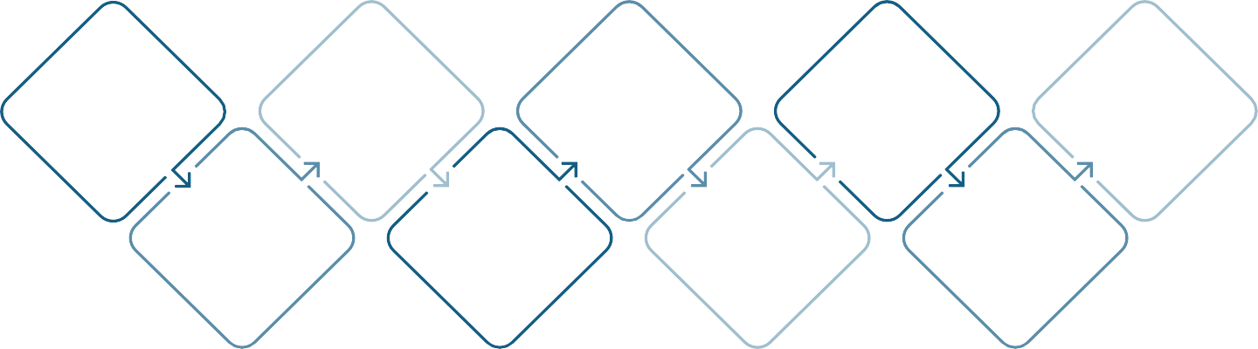

Researching prospects
Introducing products and services
Nurturing leads
Sending proposals or quotes
Closing the deal
Generating leads
Lead qualification
Delivering sales presentations
Negotiating terms

Create a list of your internal activities for each stage of your sales pipeline
Based on the stages of your organization’s sales pipeline identified above, identify the activities you typically perform for each stage.

Example: When researching prospects, how do you plan to find potential customers (consumers or businesses, or both) that could benefit from your product or service?

Pipeline Stage | Activities

Visualize your sales process
Visualize your sales process by using flowcharts differentiated with shapes and colors that guide the viewer down the path from start to finish. The sales process needs to consider activities that can be completed right away, as well as those which are dependent on a prior task.

Make your sales process measurable & adjust as needed
After identifying all your pipeline stages and the activities that go with each, list down performance metrics to assess success rate of each stage.

Sales Pipeline Stage | Sales Process Step/Activity | Performance Metric(s)

