TEMPLATE FOR
GENERATING NEW LEADS
Use this template to identify your organization’s lead generation activities.

Determine your target audience
Who do you consider your target audience? Identify their demographics, interests, behaviors, roles, and job responsibilities.

Decide on your lead generation strategy
Based on your target audience, determine your lead generation strategy: inbound, outbound, or hybrid. Use the checklist below to identify how you will generate and source your leads.

 | Inbound Lead Generation Tactics |  | Outbound Lead Generation Tactics
 | Referrals |  | Purchasing Leads
 | Content Marketing |  | Cold Calling
 | Website Form Submission |  | Email Introductions
 | Traditional Advertising |  | Networking Events
 | Paid Search Advertising |  | Trade Shows
 | Social Media Campaigns
 | Educational Seminars

Execute your tactic with solid messaging
List the lead generation tactics you’ve chosen above and identify the materials you need to execute your outreach.

Tactic | Required materials
Example: Cold calling | Develop a call script

Initiate a call to action
After identifying your tactics and corresponding materials needed to execute it, create a call to action for each.

Tactic | Call to Action
Content Marketing | After a video, article, or podcast, let the audience know they can learn more by calling a certain number, emailing your business, or submitting a website form.

Measure the effectiveness of your lead generation activities
After identifying your tactics and corresponding materials needed to execute it, create a call to action for each.

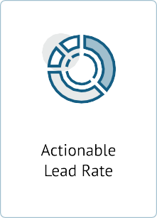
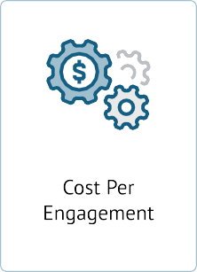
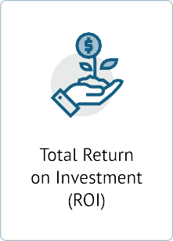
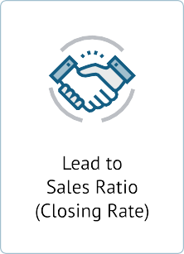

Tactic | Success Rate

6. Constantly review your strategy & adjust as needed
Based on the success rate of your tactics, identify the best and least performing activities and focus more on the ones that help you generate the most leads.

Top Performing Lead Generation Activities | Least Performing Lead Generation Activities

