

**[ Company Name ]**

Accounts Payable

**INTERNAL CONTROLS**

Manual

**Date Created**: mm/dd/yyyy

**Date Revised**: mm/dd/yyyy

**TABLE OF CONTENTS**

**Abbreviations Used 3**

**Introduction 4**

Purpose 4

Scope 4

**A/P Process Overview 6**

Organizational Chart 6

Roles & Responsibilities 6

A/P Manager 6

A/P Staff 7

Workflow 8

**Procedures 9**

Document Requirements & Submission 9

Physical Documents 9

Other Required Documents 10

Document Integrity 10

Email Submissions 10

Processing Time Expectations 11

Invoice Audit & Recording 11

Checking for Duplicates 11

Reviewing Duplicates 12

Recording 12

Three-way Matching 13

Handling Discrepancies 13

Voucher Package Preparation 14

Voucher Review & Approval 14

Payment Posting 14

Daily SL Adjustments Summary 15

GL Update 15

Discrepancies Between the GL and SL 16

**Annual Review 16**

**Effectivity 16**

**Minor Amendments 17**

**Annex 19**

Annex A - Request to Update Accounting Records 19

Annex B - Payment Voucher Form 20

Annex C - Daily SL Adjustments Summary 21

Annex D - Remittance Advice 22

# Abbreviations Used

| Abbreviation | Meaning |
| --- | --- |
| A/P | Accounts Payable |
| PR | Purchase Request |
| PO | Purchase Order |
| RR | Receiving Report |
| GL | General Ledger |
| SL | Subsidiary Ledger |

# Introduction

An internal controls manual is a comprehensive document that outlines all policies and procedures for a particular business process. This document is necessary to ensure all transactions are accounted for during the accounting period.

All employees must follow the steps, processes, and requirements to maintain a smooth flow of transactions and fast resolution of all pending requests.

## Purpose

The purpose of this A/P manual is to:

* **Standardize and streamline the A/P process:** Our goal is to provide departments and teams with a single source of information when:
  + Processing vendor invoices
  + Creating receiving reports
  + Processing vendor invoices
  + Requesting for vendor payments
  + Settling all vendor obligations, and
  + Recording all A/P transactions in the system
* **Minimize and prevent errors:** With clear guidelines in place, it is our goal to minimize and prevent the likelihood of errors before the A/P process is initiated.
* **Detect and correct errors promptly:** While some errors remain undetected before the initiation of the A/P process, this manual establishes procedures that will help the A/P team detect and correct errors as they occur through the process.
* **Promote compliance with internal policies:** This A/P internal controls manual works in conjunction with other internal policy documents in the company. Please refer to these internal policy documents for more information.
* **Mitigate fraud risk:** While the company has high regard and trust for its employees, it is still management’s responsibility to ensure that resources are properly protected and utilized. Creating an internal controls manual helps management attain its objective of protecting the company’s resources.

[ Feel free to add more details about the purpose of this manual. ]

## Scope

This manual only covers all procedures, policies, and controls over A/P. Processes that come before invoice handling (e.g., creating a purchase order) should be addressed to the appropriate department, team, or personnel. For questions or clarifications, you may reach out to the Accounts Payable Department at [ insert email address, e.g., accountspayable@mycompany.com ] or [ insert local number ].

These policies and procedures include the following:

1. Handling vendor invoices
2. Creating a voucher package
3. Reviewing the voucher package
4. Creating a payment request
5. Forwarding payment requests to the finance officer
6. Reconciling successful payments

[ Feel free to add more details about the scope of this manual. ]

# A/P Process Overview

The A/P department adheres to the company’s bylaws and internal policies. To ensure its continued compliance, this manual aims to provide all stakeholders with the needed information when processing transactions with the A/P department.

## Organizational Chart

[ This is a sample chart. Insert your company’s organizational chart for the Accounts Payable Department. If you can make it more detailed (i.e., adding names and images), that would be very informative for the users of this manual. ]

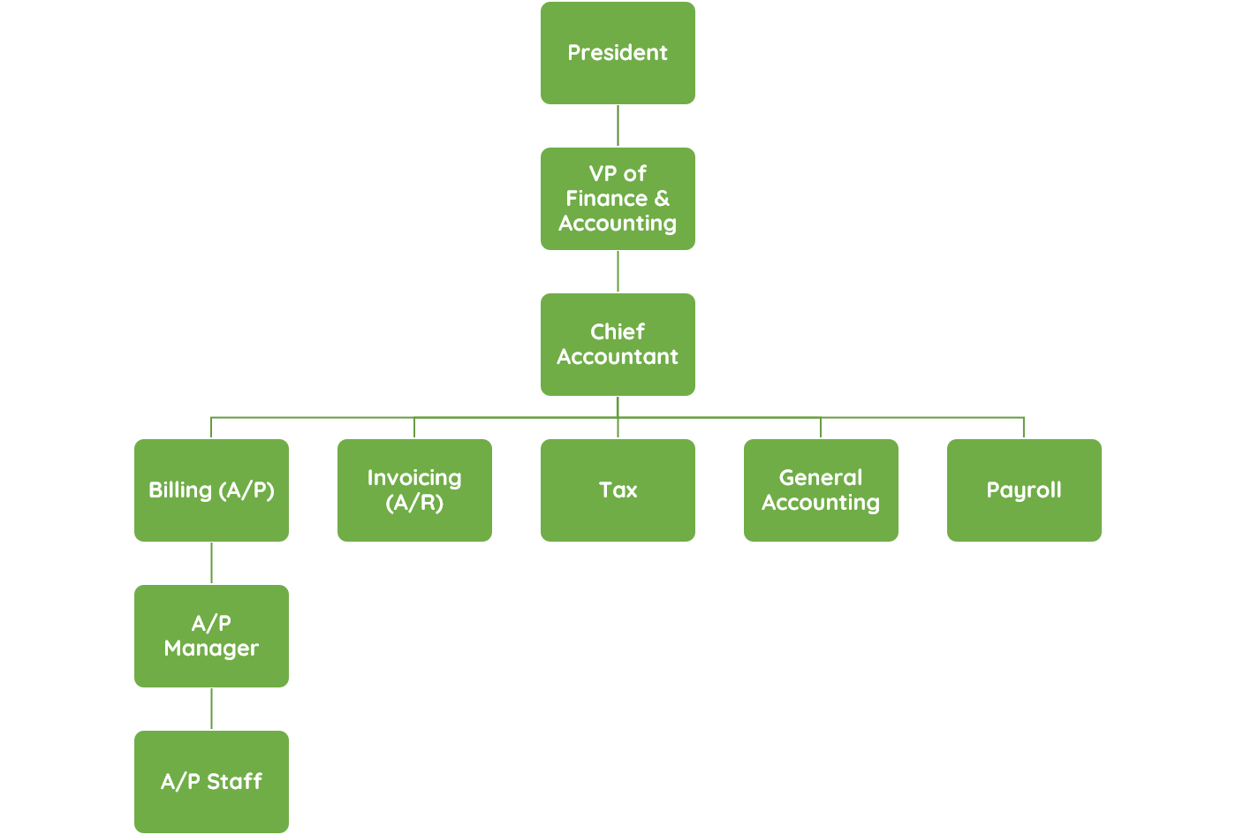

## Roles & Responsibilities

The members of the A/P department are expected to perform the following roles and responsibilities.

### A/P Manager

**Reports to:** Chief Accountant

**Department:** Finance/Accounting

**Responsibilities:**

The A/P manager is responsible for supervising and overseeing the entire A/P process. This role involves supervision of the A/P staff, timely approval of all A/P transactions, review of the A/P staff’s work, and proper implementation of this manual. [ These are generic responsibilities. We recommend replacing them with the job descriptions that your company uses for its A/P manager position. ]

Besides that, the A/P manager should also perform the following key responsibilities:

* Oversee the vendor invoice handling, entry, codification, and review process.
* Oversee the reconciliation of the A/P GL and vendor SL.
* Oversee proper recording of bills and payments in vendor SLs.
* Review, approve, and enter GL transactions in the accounting system.
* Provide expert guidance regarding accounting issues surrounding payables and expenses.
* Ensure that all A/P transactions are processed and approved promptly.
* Maintain strong relationships with vendors in case of discrepancies in billing and payments.
* Conduct spot checks to ensure the A/P staff’s thoroughness in processing A/P transactions and documents.
* Implement the in-house manual for A/P controls and perform periodic reviews of the manual for changes and updates.
* Furnish monthly and weekly reports to the chief accountant or as requested.
* Review reports created by the A/P staff before submission.
* Assist in month-end and year-end closing, especially in the A/P function.

### A/P Staff

**Reports to:** A/P Manager

**Department:** Finance/Accounting

**Responsibilities:**

The A/P staff is responsible for processing vendor invoices, reviewing and verifying transactions, scrutinizing submitted documents, and providing support to the A/P manager as needed. [ These are generic responsibilities. We recommend replacing them with the job descriptions that your company uses for its A/P staff position. ]

Besides that, the A/P staff should also perform the following key responsibilities:

* Perform vendor invoice handling, entry, codification, and review process.
* Reconcile the A/P GL and vendor SL.
* Record bills and payments in vendor SLs on time.
* Enter A/P data into the accounting system as needed.
* Liaise with other departments or personnel for specific transactions or payments.
* Coordinate with vendors in case of discrepancies in billing and payments.
* Adhere to the in-house manual for A/P controls at all times.
* Maintain and organize A/P records.
* Prepare monthly and weekly reports for the A/P manager or as requested.
* Assist the A/P manager in month-end and year-end closing, especially in the A/P function.
* Provide additional support to the A/P manager as needed.

## Workflow

The image below is a simplified illustration of the A/P workflow. This illustration aims to provide you with an idea of how transactions are processed within the A/P department. For more detailed instructions, please refer to specific sections in this manual.

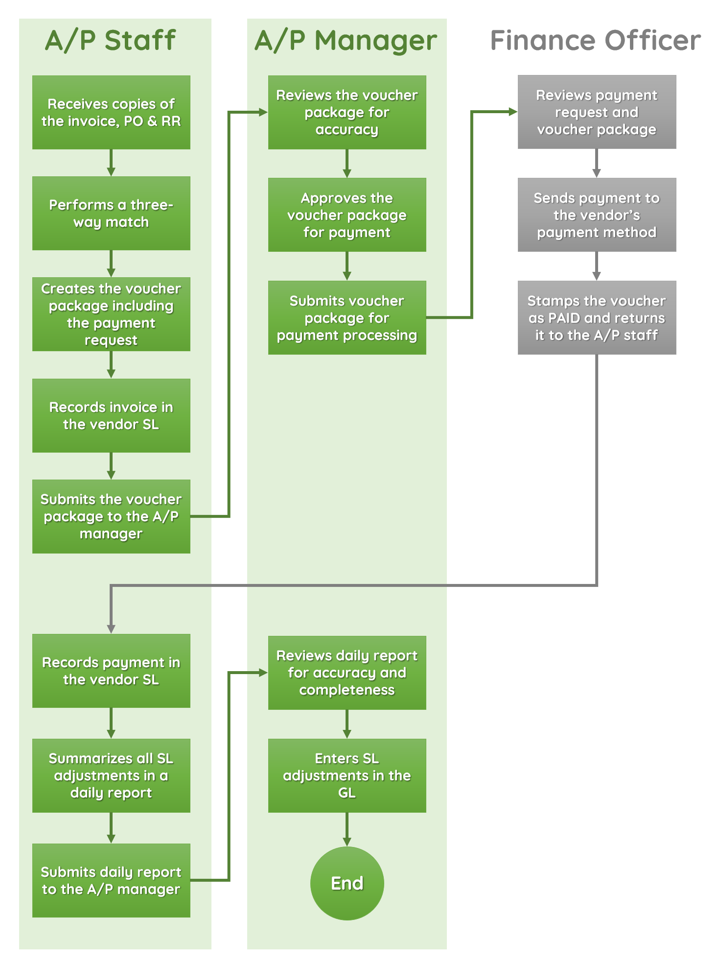

[ The image above is just a sample workflow of the A/P process. We recommend placing your company’s actual A/P workflow here. ]

# Procedures

Below are the detailed instructions that all stakeholders must follow when transacting with the A/P department.

[ These are generic procedures only. Feel free to modify or change the sections below. We recommend documenting your business’ A/P workflow. ]

## Document Requirements & Submission

To ensure the smooth processing of transactions, we recommend that concerned employees submit documents complete with all the required information. The A/P team will not accept or process incomplete documents. Please compile all the required documents prior to submission to avoid any delays in payments.

### Physical Documents

All submitted documents must have the following information. We encourage all stakeholders to always furnish the accounting department with a photocopy of submitted documents (except the vendor invoice). You may keep the original copy unless it’s asked to be submitted.

| **Document** | **Requirements** |
| --- | --- |
| **Vendor Invoice** | * Original copy of the invoice * Vendor’s name, address, and contact information * Invoice number, date, and due date * Purchaser’s name * Invoice amount and payment terms * Vendor’s payment details |
| **Purchase Order** | * Accounting copy of the PO * Purchasing officer’s signature * Date of purchase approval * Accompanying purchase requisition form or slip, if any * List of items or services ordered * Cost of items or services ordered |
| **Receiving Report** | * Accounting copy of the RR * Receiver’s signature * Date of receipt * Receiver’s examination of received goods * Quantity of goods received |

The A/P staff must stamp these documents as RECEIVED upon submission to signify that the documents have been received in the A/P department.

### Other Required Documents

Aside from those mentioned above, management may require additional documents to be submitted. Here are some commonly requested documents:

1. Signed contract
2. Memorandum of understanding (MOU)
3. Memorandum of agreement (MOA)
4. Purchase requisition form
5. Quote or estimate from the vendor
6. Progress billing report

The list above is not exhaustive. We encourage you to communicate with the A/P team for other documents that need to be submitted.

### Document Integrity

To minimize errors, issues, and discrepancies in recording, we encourage all submissions to be finalized and complete. The A/P team will decline documents that are:

1. Mutilated or damaged even in part only
2. Incomplete (missing pages, missing attachments, incomplete information)
3. Not using the proper format or form version
4. Tampered with or marked up without approval unless the changes have been countersigned by the person responsible
5. Not approved by the duly authorized person

### Email Submissions

For email submissions, please send them to [ insert email address, e.g., accountspayable@mycompany.com ].

Vendors should be reminded beforehand that invoices may be sent to the A/P department’s email address for convenience.

For email submissions, the following email structure should be observed.

| **Document** | **Email Subject** |
| --- | --- |
| **Vendor Invoice** | BILL + [Vendor Name] + [Invoice Number] + [MMM YYYY]  Example: BILL ABC Company 89294 Apr 2024 |
| **Purchase Order** | PO + [PO Number] + [Date Ordered in MMM YYYY]  Example: PO 007829 Mar 2024 |
| **Receiving Report** | RR + [RR Number] + [Date Received in MMM YYYY]  Example: RR 002349 Sep 2024 |

Upon receipt of the email, the A/P staff must acknowledge the email submission.

### Processing Time Expectations

The A/P team will process all transactions as quickly as possible and as bandwidth permits. To ensure adequate time for the team to perform their responsibilities, please align your expectations with the following processing times.

* **Document processing and review:** 1 working day
* **Voucher preparation, review, and approval:** 1-2 working days
* **Payment processing:** 2-3 working days
* **Vendor SL and GL updates:** 1-2 working days

If a payment needs to be settled early, please coordinate with the A/P manager to expedite the processing. Otherwise, all other vendor invoices will be processed according to their expected time of completion.

Please also keep in mind that documents submitted after [ insert time, e.g., 3 PM ] will be processed on the next business day. Lead time may differ depending on the A/P team’s bandwidth, which means that it may take less or more time for the A/P team to process all transactions.

## Invoice Audit & Recording

Once the A/P staff gets a copy of the vendor invoice, they must perform an invoice audit to check if the invoice is not a duplicate of a previously approved or previously paid invoice. After the audit, the A/P records the invoice in the system.

### Checking for Duplicates

To audit an invoice, the A/P staff must access the company’s dedicated A/P or accounting software to search for existing records in the system. When auditing a vendor invoice for possible duplicates, the A/P staff must perform the following:

1. **Identify duplicate indicators:** The A/P staff must review the invoice number, amount, and date.
2. **Check accounting data for similar entries:** The A/P staff must use the company’s dedicated software to check if the current invoice is already recorded or paid for by the company.
3. **Mark duplicate invoices:** When the A/P staff catches that the current invoice is a duplicate, they must stamp or write somewhere in the invoice that it is a duplicate invoice. Afterward, the A/P staff should:
   1. Check whether the invoice has been paid. If already paid, the A/P staff must reach out to the vendor and notify them that the invoice has been settled.
   2. If the invoice has not been paid, the A/P staff must check the invoice due date first before performing the following steps:
      1. If the invoice is not yet due, the A/P staff must reach out to the vendor and inform them that their invoice is currently being processed.
      2. If the invoice is overdue, the A/P staff must escalate this issue with the A/P manager immediately.
      3. The A/P manager shall inform the finance officer, in writing, that immediate payment must be made to the vendor.
      4. The A/P manager shall furnish a copy of the written notice to the chief accountant.
4. **Inform the A/P manager of other issues:** If the A/P staff finds two invoices to be a near match (i.e., strikingly similar but with minor differences), they must reach out to the A/P manager for guidance. Otherwise, the A/P staff may always communicate with the vendor to resolve these issues as quickly as possible.

### Reviewing Duplicates

When reviewing duplicate invoices, the duplicate can be an exact match or a near match. The A/P staff must carefully scrutinize the invoice in question before raising this issue with the A/P manager. There’s a possible near match when the:

* Invoice numbers have similar unique identifiers, characters, or symbols.
  + Invoice 00267 vs 00267R
  + INV00267 vs INV 00267
  + INV-00267 vs INV_00267
  + inv00267 vs INV00267
* Invoice dates are very close to each other (e.g., issued one day apart).
* Invoices have different information but have the same PO number.
* Invoices have different dates but have the same amount and description of items ordered.

### Recording

Once the A/P staff clears the vendor invoice, they must record the invoice in the system—subject to the approval of the A/P manager.

**Important Control Mechanisms:**

1. The A/P staff and A/P manager must only have read-only and write-only permissions in the system, i.e., they’re not allowed to edit or delete existing records.
2. The A/P manager may request, in writing (see Annex A), changes in the records—subject to the approval of the chief accountant. The A/P manager must clearly outline to the chief accountant why the change is necessary.
3. Once approved, the chief accountant will go in and make the changes themselves. The written request must appear on the record so that there’s a documentary trail for changes within the system.

Management encourages all stakeholders to ensure that all information furnished to the A/P team is finalized and correct. Requests for changes entail additional administrative work for the A/P team, which may derail the review and approval of pending invoices.

## Three-way Matching

A three-way match ensures that the invoice, PO, and RR all have the same information. Three-way matching enables the A/P team to verify the correctness of a transaction if several documents can vouch for it. The A/P staff performs a three-way match after invoices have been audited and recorded.

Here are the general guidelines for the A/P staff to follow:

* The items, quantities, and descriptions of items received per RR must match the items, quantities, and descriptions of items ordered per PO.
* The items, quantities, and descriptions of items ordered per PO must match the items, quantities, and descriptions of items invoiced per vendor invoice.
* The price and terms in the vendor invoice must match the price and terms in the PO.

### Handling Discrepancies

When discrepancies arise, the A/P staff or manager must perform investigations or reach out to responsible persons to provide more clarity on the issue.

| **Discrepancy** | **Actions** |
| --- | --- |
| **Quantity** | * Match the document with other related documents * Check the system for partial shipments or shipments that are still in transit * Reach out to the receiving personnel to clarify if there is a clerical mistake in the accounting copy * Request the receiving personnel to recount the goods only if necessary |
| **Amount** | * Match the document with other related documents * Check if the invoice is a credit or debit invoice * Review the contract for pricing * Foot the invoice to rule out mathematical inaccuracies |
| **Item Description** | * Match the document with other related documents * Reach out to the receiving personnel to re-inspect the goods received * For high-value goods, perform a physical inspection of the goods delivered * Check if some items were substituted |

As much as possible, reach out to the vendors only if the discrepancy is not an internal issue (i.e., errors committed by an employee).

## Voucher Package Preparation

The A/P staff must prepare the voucher package and forward it to the A/P manager for approval. The voucher package must contain the following documents:

1. Original copy of the vendor invoice
2. Accounting copy of the PO
3. Accounting copy of the RR
4. Payment voucher (See Annex B)
5. Additional documents as required

The voucher will be forwarded to the A/P manager for final review and approval.

## Voucher Review & Approval

The A/P manager shall verify and review the correctness, accuracy, and completeness of the voucher package prepared by the A/P staff. In this process, they must:

* Verify the completeness of the documents submitted.
* Cross-check the invoice with the invoice record entered by the A/P staff in the system.
* Perform a second three-way match to ensure the accuracy of the information.
* Review the mathematical accuracy of all documents with quantities and dollar amounts.

After review, the A/P manager may approve or reject the voucher. In case of rejection, the A/P manager must leave a note anywhere in the voucher regarding the reason for rejection.

Approved vouchers are then forwarded to the finance department for payment processing. For payment processing lead time, kindly coordinate with the finance officer.

## Payment Posting

After the finance department settles the vendor invoice, the voucher is returned to the A/P department for payment posting. The A/P staff shall receive the paid vouchers for posting.

Prior to the posting, the A/P staff must check the following:

* The payment voucher must be stamped PAID by the finance officer.
* The payment details are legibly written or shown in the voucher.
* The person who paid the voucher is the authorized person to do so.
* The remittance advice (See Annex D) prepared by the finance officer must be attached to the voucher package.

Should there be any concern about the payment, the A/P staff should raise this issue to the A/P manager for guidance or coordinate directly with the finance department for a faster resolution.

The A/P staff should record the payment to the vendor’s SL account as a pending adjustment and log the payment posting to the daily summary.

## Daily SL Adjustments Summary

Part of the A/P staff’s responsibility is to maintain a daily summary of vendor SL adjustments. They must utilize the Daily A/P Subsidiary Ledger Adjustments Summary (see Annex C). [ You may opt to use spreadsheets for this purpose. ]

At the end of the business day, the A/P staff must submit their daily summary to the A/P manager for review, approval, and posting. The amounts posted in the SL must match the amounts reported in the daily summary.

## GL Update

The A/P manager is responsible for maintaining the organization, orderliness, and accuracy of the A/P account in the GL. Daily, they must review SL adjustments created by the A/P staff to check the accuracy and completeness of all vendor SL adjustments during the day.

When approving SL entries made by the A/P staff, the A/P manager must:

1. Ensure that descriptions accurately reflect the nature of the transactions.
2. Verify the amounts debited or credited with the amounts reported in the daily summary.
3. Check the reference numbers and account numbers.
4. Perform mathematical checks to ensure the sum of amounts.

When updating the GL, the A/P manager must:

1. Make only a single entry that summarizes all changes across all SL accounts.
2. Ensure that the net adjustment to A/P matches the net adjustment in the daily summary.
3. Investigate any unusual line items in the daily summary.

### Discrepancies Between the GL and SL

When there is a discrepancy between the amounts reported by the GL and SL, good accounting practice dictates that the SL balance prevails. The A/P manager must exercise caution in finalizing adjustments to the A/P account.

The A/P manager must be conservative and postpone GL updates until the discrepancies have been resolved. Escalating the issue to the chief accountant may be necessary for additional guidance and oversight.

# Annual Review

The accounting department shall conduct an annual review of the manual for significant updates in policies and procedures. Should there be no amendments proposed, the effectivity of the manual shall continue to be enforced. Minor amendments shall be dealt with accordingly as proposed by the A/P manager and approved by the chief accountant. Major amendments shall require the approval of the VP of Finance & Accounting.

# Effectivity

This A/P manual shall be effective starting [ insert date ]. All stakeholders are expected to adhere to the policies and procedures included in this manual.

Proposed by: Reviewed by:

[ Signature ] [ Signature ]

[ Name ] [ Name ]

Accounts Payable Manager Chief Accountant

Approved by:

[ Signature ]

[ Name ]

VP of Finance & Accounting

# Minor Amendments

[ If there are amendments to the manual, specify the amendments here for transparency. A sample amendment is shown below; please delete the sample. ]

**Jan 15, 2024**

(Light yellow highlights are provisions that didn’t exist in the old version of the manual.)

For email submissions, please send it to ~~accounting@mycompany.com~~ accountspayable@mycompany.com.

Vendors should be reminded beforehand that invoices may be sent to the A/P department’s email address for convenience.

For email submissions, the following email structure should be observed.

| **Document** | **Email Subject** |
| --- | --- |
| **Vendor Invoice** | BILL + [Vendor Name] + [Invoice Number] + [MMM YYYY]  Example: BILL ABC Company 89294 Apr 2024 |
| **Purchase Order** | PO + [PO Number] + [Date Ordered in MMM YYYY]  Example: PO 007829 Mar 2024 |
| **Receiving Report** | RR + [RR Number] + [Date Received in MMM YYYY]  Example: RR 002349 Sep 2024 |

Upon receipt of the email, the A/P staff must acknowledge the email submission.

Proposed by: Approved by:

[ Signature ] [ Signature ]

[ Name ] [ Name ]

Accounts Payable Manager Chief Accountant

# Annex

### Annex A - Request to Update Accounting Records

[ This is a sample format of the request form. Please attach the form that your company is using. ]

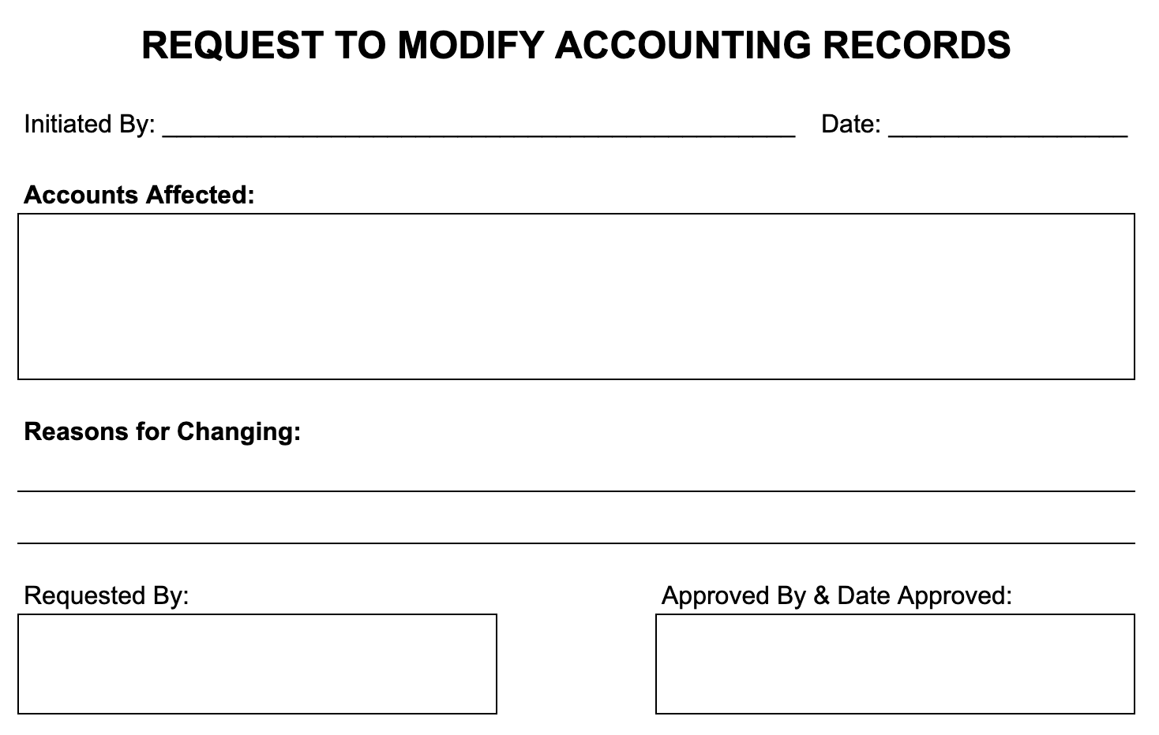

### Annex B - Payment Voucher Form

[ This is only a sample of the payment voucher form. Please attach the form that your company is using. ]

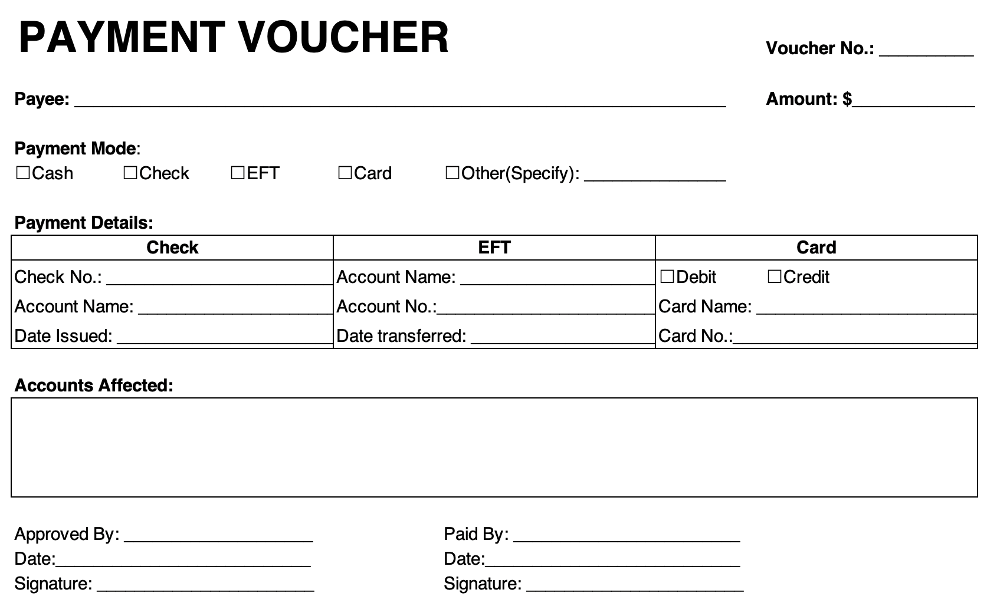

### Annex C - Daily SL Adjustments Summary

| **DAILY A/P SUBSIDIARY LEDGER ADJUSTMENTS SUMMARY** | | | |
| --- | --- | --- | --- |
|
| Prepared By: _____________________________________ | | Date: _____________________ | |
|  |  |  |  |
| **Description** | **Account No.** | **Debit** | **Credit** |
|  |  |  |  |
|  |  |  |  |
|  |  |  |  |
|  |  |  |  |
|  |  |  |  |
|  |  |  |  |
|  |  |  |  |
|  |  |  |  |
|  |  |  |  |
|  |  |  |  |
|  |  |  |  |
|  |  |  |  |
|  |  |  |  |
|  |  |  |  |
|  |  |  |  |
|  |  |  |  |
|  |  |  |  |
|  |  |  |  |
|  |  |  |  |
|  |  |  |  |
| **SUMMARY** |  |  |  |
| **Total amounts credited** | $ |  | Signature: |
| **Total amounts debited** | $ |  |  |
| **Net adjustment to accounts payable** | $ | _____________ | |

### Annex D - Remittance Advice

